BỘ VĂN HÓA, THỂ THAO VÀ DU LỊCH
TRƯỜNG ĐẠI HỌC VĂN HÓA HÀ NỘI

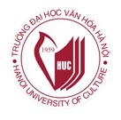

CHƯƠNG TRÌNH MÔN HỌC

TIẾNG ANH HƯỚNG DẪN DU LỊCH
MÃ MÔN HỌC: DL6022

NGƯỜI BIÊN SOẠN
LÊ THANH TÚ

HÀ NỘI – 2023

Foreword
In Vietnam, English is of great necessity in the innovation and development, principally in the modernization and industrialization of the country. It is a compulsory subject at universities. At the advanced level, there should be different sorts of materials of English for different purposes appropriate for students’ specialties and it will be great help for them after graduation.
English for tour guiding services is designed for college and university students who are trained for Tourism Industry in Vietnam. This document is specially designed for the fourth year students of Tourism Faculty of the Hanoi University of Culture. It provide materials for improving the knowledge and understanding required to become professional tour guides
This document has been designed on the basis of the current theories and practices for tour guide services to help tourism students to be aware of the main needs of English. This is the one to practice to ensure the perfection of English for tour guides.
In this course you will be provided a large number of words and phrases as well as useful information for tourism in tour guiding services. With teacher’s help, students will not only learn how to do in the operation process of a tour guide in English but also build an interesting and well-organised commentary and have a good chance to practice speaking skills and presenting things.
This document sometimes provides the texts from variety of sources with pre-reading questions, vocabulary, various kinds of exercises for practice complied in a way that helps students become more positive and self-confident. It may possible be better exploited if the students are encouraged to promote their self-study to the great extent.
The document may still have limitation. I look forward to receiving our colleagues and students ‘comments on how it can be improved, amended and supplemented.

Table of contents
Page number
Foreword
Unit 1. Greeting and welcoming tourists 1
Unit 2. Briefing itineraries 4
Unit 3. Guiding commentary on the way 8
Unit 4. Dealing with tourists’ complaints 12
Unit 5. Explaining safety, rules, etiquettes and customs 15
Unit 6. Making introduction on the weather and climate 20
Unit 7. Telling a legend 25
Unit 8. Suggesting places of interest to visit, Closing a tour 32
Unit 9. Temple of literature – School for the sons of the nation 41
(Brief in troduction)
Unit 10. Temple of literature – School for the sons of the nation 47
(Architecture)
Unit 11. My Son sanctuary 54
Unit 12. Hue royal city 62
Unit 13. Hoi An ancient city 69
Unit 14. Revision 76

Unit 1: Greeting and welcoming tourists
Warm-up
- How is greeting and welcoming tourist so important?
- What are the most common ways of greeting throughout the world?
- How would you talk to show greetings and welcoming to foreign tourists in English?
Activity 1
Study the following expressions and discuss with your classmates when we use the expressions
Good morning/Good afternoon/Good evening/ Good night
Hello
Welcome to…
How are you?
How are you today Mr. A?
How was the flight/travel Sir/Madam?
Can I help you with your luggage, Mr. A?
Please, get into the bus
Mind your head.
Be careful.
Watch your steps.
On behalf of
Is everyone in?
The bus to the hotel will take about…/It will take us about … minutes to reach the hotel.
Please enjoy your holiday.
Have a nice vacation!
Ativity 2
Read the following greeting, welcoming and introducing one’s self to tourists at the airport and in the bus
Greeting, welcoming and introducing onself
When meeting members of a tour on arrival, a guide performs the following activities such as greeting, welcoming and introducing himself. In introducing himself, the tour guide include his full name, tour opertator’s name, business address and other supporting information. Some examples of greeting, welcoming and in troducing one’s self are as follows:
- Good morning, welcome to Hanoi. I am Nguyen Duc Long, your tour guide. I’ll tell you all about the things you will see. If you have any questions, you will be free to ask. It is my job to answer your questions. All my time is free to talk to you. Thank you.
- Good afternoon everyone. My name is Pham Phuong Linh. On behalf of Saigontourist, I would like to welcome you all to Hanoi. The bus ride to your Melia Hotel takes you about 30 minutes. Right now I’d like to take a minute to familiarize you with the area and tell a brief safety precaution. You have to fasten your seatbelts and remained seated until we reach our destination.
- Dear visitors, I would like to welcome you all to Hanoi. Let me introduce myself first. My name is…. I am your tour guide and will support you during the tour. I promise you are going to enjoy your stay here in Hanoi. This is a beautiful and peaceful city where you can relax, visit historical vestiges, enjoy great meals and feel comfortable. You can take a walk in the city, take pictures.
- Good morning everyone. Welcome to Hanoi. I’m your tour guide, Phuong. It’s great to meet you here in Hanoi. You will discover that Hanoi and the surrounding are beautiful and interesting. You will find there is more to see in Hanoi than you have dreamt about.
- Good afternoon, lady and gentlemen. I am Lan, your tour guide today. We are going to be pulling up to the hotel in just a few minutes. Please sit back and enjoy the view of the shopping centre on the left hand side of the bus as we enter the city. I would like you all to remain in your seats until you we have come to a complete stop. Our agent, Mr. Long will be meeting you at the bus to help you with your bags. Please double check to make sure bag has taken off the bus. On behalf of Viettravel company, have a wonderful vacation in Hanoi and I hope to see you tomorrow at the information session.
Practice greeting, welcoming tourist and introducing yourself with your partner. You have to change some of the information such as the time, name of the guide, place and travel agent.

Activity 3
Fill in the blanks with the missing words or phrases in the following greeting, welcoming and introducing oneself.
- Good evening. My name is………a………. I am your tour guide today. I would like to welcome to………….b………….. My job is to help you tell all about the thing you will see. It ….c…… my pleasure to answer your questions. It is free to talk to me at ………d…….. you need my help. Thank you.
- Good morning ladies and gentlemen. I am………….a……….. On behalf of………b……………. I would like to welcome you all to ………….c……… …. Our tourist bus ride to the hotel will take about……..d……. minutes. Now I would like to spend a minute to familiarize you with the area and discuss some …….e………… for safety. Firstly, I would like you all to remain seated until we reach our destination. Secondly, I would like………….f…………. that is against the law to get drunk in public. Enjoy your holiday with us.
- Good morning, everyone. I am your tour guide today. My name is………a……… I am happy to welcome you to………b…………. It is a great pleasure to meet you here………..c..…………… You will find that…………d…………. and the surrounding are very………….e…………….and ………f…………. You also discover that there are many ………….g……….. in ……….h………….
- Good day, everyone. My name is……………a…………, your tour guide for today. We are going to leave for the hotel in ………….b………….. You can …………..c…………… on both sides of the bus as we enter the city. I suggest you to remain in your seats until our bus …………..d………….. Our agent, ……….e…………. will be meeting you at the bus to help you with your bags. Please double check to make sure your personal belongings are not……….f……….. On behalf of………g……………, have a wonderful vacation in Hanoi and I hope to see you tomorrow at ………….h…………..
- Good afternoon everyone. I would like to welcome you all to……….a……………. Please, let me introduce myself. My name is……..b………… I am your tour guide and will support you during the tour. I promise you are going to enjoy your stay here in …………c………… This is a beautiful, unique and famous city in Vietnam. You can enjoy……….d………… and explore great culinary activities. The best restaurant serving various culinary products in this city is..........e…………….. You can also enjoy………….f………

Activity 4
Work in pair to write down what a tour guide has to perform when greeting, welcoming tourist and introducing himself. Demonstrate in front of the class and minimize to look at what you write

Unit 2: Tour Briefing
Warm-up
- What is a tour briefing?
- When is a tour briefing given?
- How many parts are there in a tour briefing?
A tour briefing is usually for travel agents and tour guide and intended to make tourists acquainted with a new destination or new procedures. It is held often before leaving for a destination in a tourist bus or some near the bus in the parking area. This is also often given before entering a place of interest to deliver the entrance ticket, to remind the local regulations, to tell the length of the visit, etc.
Activity 1
Study the following information about briefing. In the briefing, there are three main parts to be considered by a tour guide. The contents of each part are as follows:
- Opening
- Welcoming remark
- Introducing yourself on behalf of the company.
- Introducing the driver, co-diver especially for briefing.
- Main information about the tour
- Short information about the destination
- Places of interest or attractions to be visited day by day
- Route of the tour
- Time to get to the places of interest or attractions.
- Estimating time of the tour, on the way, at the places, lunch, shopping, etc.
- What they can see on the way, on the spots.
- Where they will stay, shop, eat.
- Health and safety: deceases being spread and the prevention
- Tour regulation: going to toilet, time
- Local regulation: no footwear, taking pictures, etc.
- Optional tour if applicable – offer and decide.
- Closing
- Last greeting.
- Ask the guests to get into the bus, reminds their steps. It is for briefing out of the bus.

Activity 2
Study the following common expressions for briefing
Welcome to…
Welcome to our first day tour
How was your sleep last night? /Did you sleep well last night?
On behalf of …., I would like to thank you for
My name is… and you can call me…..
Let me introduce myself, I am…/First of all I’d like to introduce myself, I am your tour guide today.
Let’s get into the bus
Mind your steps
Watch your head
Be careful, it’s a bit wet and slippery.
Our programme for today is visit…
Our diver is Mr…., a very experienced driver.
His experience guarantees the safety of our trip
Activity 3
Study the following one day Ha Noi – Ha Long tour itinerary which will be used as the main information for briefing
Ha Long one day
ITINERARY DETAILS
TIME: 1 day
TRANSPORT: cruise
ORIGIN: Hanoi
DESTINATION: Ha Long bay

07:30 Depart to Ha Long Bay from our shuttle bus pick up points at Home Finest Teas Lounge, Ground Floor, Office Building, Hanoi Towers, 49 Hai Ba Trung Str., Hoan Kiem Dist., Hanoi.
10:30 Boarding on Paradise Explorer and enjoy some light refreshments while the boat is heading towards some incredible landscapes in the famous UNESCO World Heritage Site.
12:00 – 13:00 Savor your lunch aboard Paradise Explorer and adore the stunning scenery of the famous Fighting Cocks Islet, Thien Cung and Dau Go caves along the way.
13:00 – 14:00 Your first excursion is the magnificent Sung Sot Cave where you will be surprised by the breathtaking panoramic view across the Bay once you exit the cave. This is the largest cave in Ha Long Bay, and the stalactites and stalagmites formed over millions of years have taken on fascinating shapes.
14:30 – 15:30 Don’t miss the fun at Luon Cave – one of the best places for kayaking (with surcharge VND 550.000 per kayak per time). If you wish to just enjoy the view, a bamboo boat will bring you inside.

15:30 – 16:15 Your next stop is Ti Top island to hike to the top for stunning panoramic views of the Bay. After your hike, go for a refreshing swim in Ha Long Bay’s emerald waters or sip from a coconut in the shade you can hike to the top for stunning panoramic views of the Bay or enjoy a refreshing swim in Ha Long Bay’s emerald waters.
16:20 – 17:20 Indulge yourself in a 30 to 60-minute of foot reflexology with our specialists from Le Parfum Spa or savor a drink on board whilst the Paradise Explorer is getting back to Tuan Chau Marina.
17:30 Return to Hanoi from the harbor. End of service.
Source: Saigontourist - HA LONG 01 DAY (saigontouristvietnam.com)
Activity 4
Study the following tour briefing conducted by a tour guide. This briefing that is conducted prior to the tour has some missing information as listed below. Put the following missing words or phrases into the right blank spaces.
(….) experienced driver
(….) for our company
(….) I hope you
(….) I told you
(….) for kayaking
(….) indulge yourself
(…) board on
(….) hike to the top
(….) in the toilet
(….) return
(….) our co-driver
(….) please do not litter
(….) will spend
Tour briefing
Good morning ladies and gentlemen. Welcome to our first day tour. How was your sleep last night? I hope you could sleep well. I’m your tour guide and…….a…….. still remember my name. Oh yes, David, thank you. Our driver is Mr. Tuan, a vey ……..b………... He has been with us for 12 years. He is the best driver ………..c…………. His experience guarantees the safety of our trip.
Ladies and gentlemen, and …………d……… who will also help to keep the cleanliness of our bus is Mr. Hung. He suggests that keeping the bus clean is our job. So, ………e……….. but put the rubbish into the trash can available, thank you.
Let’s have a look at our itinerary. We are going to leave the hotel for Ha Long Bay. It will take nearly 3 hours to go there. As……..f…….. yesterday, Ha Long Bay is made up of 1,969 islands of various sizes. This densely concentrated zone of stone islands, world famous for its spectacular scenery of grottoes and caves. First, we will……..g…….. Paradise Explorer to go sight - seeing Sung Sot cave, a very beautiful and magnificent one. We …………h…….. about 60 minutes there. Then, we will go to Luon cave ………..i……………. for one hour. I notice everybody is wearing life – jackets. Your next stop is Ti Top Island where you can………j………. for stunning panoramic views of the Bay, then go for a refreshing swim. The water is said to be transparent as emerald. Are you ready with your swimming suit? We will spend 45 minutes there.
After that, you can ………….k……….. in a 30 to 60-minute of foot reflexology with our specialists from Le Parfum Spa or savor a drink on board while the Paradise Explorer is getting back to Tuan Chau Marina. This activity will end at 17.30. We’ll ………..l……….. Hanoi from the harbor.
Now, let’s get into the bus. Mind your steps. Let me check to make sure that everybody is here. Mr and Mrs. Black, Mr Lee, Ms. Nelson is there, Mr. White, not yet here. He is still ………….m…………... Oh, there he is. All right, it is time to go.
Activity 5
Work in group of three to write your speech in conducting briefing basing on itineraries you have had.
Activity 6.
Conducting briefing presentation. Present in front of the class how you conduct briefing presentation based on what you have done in Activity 5

Unit 3: Guiding commentary on the way
Warm-up
- What will tour guide inform to tourists on the way to the tourist destination?
On the way to the destination, a tour guide can inform a lot of things. He can comment on the attractions at the site of the road, the landmarks, the condition of the road, the trafific jams, trafific accident, blocked road, roadwork, previewing the attractions or places of interests to visit and reviewing them. The guide is also ready to give any historical, political, or other (background) information, jokes to the tourist.
Activity 1
Study the following useful expressions
It will take....minutes to go to...
Now we are approaching....
We are now directing South
We are now directing North to...
We are heading West.
On our left is.. and our right side is...
On your right, we can see....
If you look over to the right now you can see...
Alright, now we are on .....Mountain
We are now entering ...
We have here on your left/right
In front of you is
On the same side we also have...
We are approaching a very attractive..
We will be here for.. hours
Welcome to...
Now ladies and gentlement, we are ariving at....
It’s time to get off the bus
Watch your steps
Mind your head
It is a bit slippery. Are you alright?
Oh my god, look at your right. It is an accident.
Before you start, I’d like to tell you about the route
Our visit today will last.....
Thank you for your attention.
Activity 2
Produce a tour map with some landmarks showing the route of your tour from the hotel to the places of interests and back to the hotel.
Activity 3
Learn the following guiding commentary on the way from Sheraton hotel to Tangkuban Perahu based on the map. Fill in the blanks with the suitable prepositions in the guiding commentary.
(…) around (….) of
(….) at (…..) of
(….) down (….) of
(….) for (…..) on
(…..) for (…..) with
(…..) for (….) on
(…..) from (…..) to
(…..) in (…..) with
On the way from Sheraton hotel to Tankuban Perahu
Ladies and Gentlemen now we are leaving for Tangkuban Perahu. We are directing south along Haji Juanda Street, which is often called Jalan Dago. The word “dago” is "derived …….a……. padago-dago meaning “waiting one another”. This road used to be a place where people were waiting one another. We will go to the right …..b…..the traffic lights down there …..c……. Jalan Siliwangi. This is Jalan Siliwangi, …..d….. there…..e…. your left, you will see Sasana Budaya Ganesha meeting and exhibition building.
….f….. your right, this particular area called Jalan Siliwangi is famous ……g…….. its graffiti wall. That huge and long wall has been the media ……h………… young artists to express and give freedom ……i………..themselves. Interestingly, the brilliant idea ……j……. Bandung city mayor sice ………k……. twenty years ago has collaborated ……l……. the campus to make the Siliwangi graffiti wall as the program …….m…… freshmen and art students ………n………. Bandung institutions. The graffiti has become one…….o………… the tourist attractions …….p….. Bandung.
Activity 4
Fill in the blanks with the main verbs or predicates of the sentences in the guiding commentary.
(….) are (…..) is
(…..) are provided (…..) is
(…..) are turning (…..) sells
(…..) come (……) turn
(…..) has (…..) was
(…..) have (…..) will be
(…..) is (…..) will still go
(…..) is (…..) are entering
Still on your right, you can see Cikapundung river terrace. It has just been built by the recent mayor of Bandung, Ridwan Kamil. There……a…… an amphitheatre which consists a small podium, a big podium, and a large open plaza at the Babakan Siliwangi’s Bridge area. Several other facilities such as facility maintenance operations, joggings track, sumptuous gardens, outdoor sculpture area, natural area, education area, some structured landscape ………b…… The commercial spot area…..c….. a food court, souvenir shops and food stalls. As for the dam area, there …..d…. Leuwi Limus rafting and tubing.
Now, we are on Jalan Cihapelas but we…e… to the right and right again at the crossroad to Jalan Ciparanti. At the end of Jalan Ciparanti, we ….f…. straight on the Jalan Setiabudhi. Now we….g…. Jalan Ciparanti. Ladies and gentlemen, on your left that ….h…. the biggest fashion shop in Bandung called Rumah Mode. It ……i….. exported clothes. Many foreign people …..j….. to this shop to find the right size and good quality of clothing. I am sorry we …..k ….. a little traffic jam here. Just after Rumad Mode, on your right, that….l…. Sari Sunda Restaurant that serves Sundanese food. It ….m….. favourite traditional local food which is quite healthy because of the balanced nutrition and texture. There ….n… no entry side to go straight on, we …o…. left here and right to Jl. Setiabudhi again. We …p…. now on the business area, there are some shops, supermarkets, banks, and restaurants on both sides of the street.
Activity 5
Fill in the blanks with the right subjects of the sentences in the guiding commentary.
(…) it (…) Villa Isola or Bumi Siliwangi
(…) the building (…) we
(…) the road to Tangkuban Perahu (…) we
(….) the traffic (….) we
(….) This building (…) we
(…) this historical building (…) you
(…) This school, (….) you
Just after the traffic lights on the right, there is a Tourism School, the oldest in Indonesia. ….a…. which is popularly known as Enhaii, trains their students to work for tourism industries such as: tourism destination hotel, restaurant, or travel agent, MICE business, etc. On your left …..b….. can see a teacher college, which is now changed to University of Education (UPI). ….c… which is now called Bumi Siliwangi, is a uniquely constructed building situated 8 km North of Bandung. …..d….. is a great example of Bandung Art Deco built by an Italian millionaire, named D.W. Berrety in 1825 which is now used by UPI Bandung (Education University of Indonesia). Great views of Bandung are visible from here. Later …..e… occupied by Italian aristocrat, was used as the headquarter of some Indonesian youths who were struggling for our independence. At present….f…. is used as a rectory of the university.
Ladies and Gentlemen, …..g…. is a bit winding. During the weekend, it’s very crowded and ….h… moves very slowly. ….i…. takes hours to get up there to Mt. Tangkuban Perahu. On your right up there, ….j…. can find the Bosca Observatories. ….k….. can telescope stars in the sky but of course in the evening when the weather is bright enough. Now, ….l…. are approaching Lembang. On your right, …..m…. can see a flower plant market, various plants included flowers are sold here.
Down there to the left, …o… will go up the mountain of Tangkuban Perahu which means overturned boat.
Activity 6
Work in group of three to write down your guiding commentary on the way from the hotel to places of information based on your tour map.
Activity 7
Group presentation. Each group presents guiding commentary in front of the class.

Unit 4: Dealing with tourists’ complaints
Warm up
- In what ways could tourist complaint about the tour?
- How would a tour guide handle the complaints?
Customer complaint is an expression of dissatisfaction with a product or service, either orally or in writing, from an internal or external customer. A customer may have a genuine cause for complaint, although some complaints may be made as a result of a misunderstanding or an unreasonable expectation of a product or service. How a customer complaint is handle will affect the overall level of customer satisfaction and may affect long-term customer loyalty.
Activity 1
Some useful expression
Making a complaint
I have a complaint to make…
Sorry to bother you but….
I’m sorry to say but….
I’m afraid I’ve got a complaint about…
I’m afraid there is a slight problem with
Excuse me but there is a problem about..
I want to complaint about…
I’m angry about…
I’m afraid I have to make a complaint
I’m so sorry to trouble you but, but….,
I have got a bit problem, you see
I’m so sorry to say this, but…
Excuse me, there seems to be something wrong with…
I’m sorry to say this but…
Apologizing
I am sorry…
I am sorry to hear that…
Oh, I am sorry about that..
Oh dear, I am really sorry
I apologize..
I would like to apologize for
I apologize for the inconvenience…
Please accept our apologises for ..
We are very sorry to hear that
I am so sorry, but this will never happen/occur again.
I am sorry, we promise never to make the same mistake again
I am really sorry; we will do our best not to do the same mistake again
Giving reasons
This was because…
The main reason for this ….
Unfortunately, this was unavoidable as…
I am sure that we can sort it out…
I am glad that you have brought this to our notice
Please, tell me exactly what the problem is…
Taking actions
I suggest you leave it with us and we will see what we can do
I will send you someone to take care of it.
Let me check and see what happened.
Let me have a look at it and I will get back to you
I promise you that it won’t happen again.
In the future we will…
Sorry there is nothing we can do about it
I am afraid, there isn’t much we can do about it
We are sorry but the food is just alright.
Activity 2
Study the following dialogue
A tourist complains about the food served
T: Tourist
TG: Tour guide
T: Good afternoon.
TG: Good afternoon, sir. How may I assist you?
T: You know, our lunch is not healthy. The fish served smells bad and there are many flies here. What kind of restaurant is this?
TG: I am so sorry to hear that. About the fish, we have to tell the waiter and can ask him to replace it. We can also ask him to light candle.
T: Can we?
TG: Yes of course, sir. I suggest you to move to the air-conditioned room over there. Let me escort you to that room.
T: Ok, that’s better. Thanks!
TG: My pleasure, sir!

Activity 3
Work in group to write the dialogue of complaint involving tourist and tour guide, then demonstrate it in front of the classroom

Activity 4
Practice the dialogue by changing some of the information such as name of tourist or guest, the thing to be complained, etc.

Unit 5: Explaining safety, rules, etiquette and customs
Warm – up
- What is the safety?
- What is the rule?
- What is the etiquette?
- What is the customs?
Safety is the state of being “safe”, the condition of being protected from harm or other non-desirable outcomes. Rule is an acceptable principle or instruction that states the way things are or should be done, and tells you what you are allowed or are not allowed to do. Etiquette is conventional requirements as to social behaviour; proprieties of conduct as established in any class or community or for any occasion. Customs is a traditional practice or usual way of doing something followed by a social group of people.
Activity 1
Match the following words on the left column with the meanings on the right column by writing the letters
Words | Meanings
- Adhere | (…) a route or track between one place and another, or the direction in which something is moving
- Customary | (…) an action that is done to prevent something unpleasant or dangerous happening
- Designate | (…) an official rule or the act of controlling something
- Disrespectful | (…) lack of respect
- Path | (…) the system of rules and acceptable behaviour used at official ceremonies and occasions
- Precaution | (….) the way you deal with or behave towards someone or something
- Protocols | (….) to avoid doing or stop yourself from doing something
- Refrain | (…) to stick firmly
- Regulation | (….) to say exactly how something must be or must be done
- Scripted | (…) to say officially that a place or thing has a particular character or purpose
- Stipulated | (…) traditional
- Treatment | (….) written before it is read or performed

Activity 2
Study the following information about explaining Rules, Safety, Etiquette, and Customs.
Rules, Safety, Etiquette, and Customs.
The main responsibilities of the tour guide are to explain all the safety protocols, and rules as well as the etiquette that must be adhered to during the tour, answering any of the questions that the tourists may have about the tour or the destination, to explain the places of interest that will be visited during the tour and they must be able to retain historical facts, anecdotes, and dates, then be able to discuss this information with the visitors in an entertaining, and simple to understand manner.
The first and one of the most important things any tour guide will need to do will be able to explain all the safety regulations and rules which the tour has stipulated for the tour as well as the etiquette that they must adhere to. This is easily done because most tour companies will have a scripted set of rules and regulations as well as expected etiquette.
When giving a tour there are rules and safety precautions that you need to explain. It is the best if you can inform them without reading from a card. People will pay more attention to you and understand you more clearly if you look into their eyes as you speak. After you have explained the rules and safety precautions make sure that guests have understood you, by asking, “Are there any questions about this?” or “Is everyone clear on the rules?” Also, tourists will appreciate any helpful advice you can give them, such as where to exchange their money, what types of transportation to use, and how to obey the traffic rules. Finally, if there are any customs or matter of etiquette that you think tourists should be aware of, this is a good time to let them know.
Rules of the tour
- you are strictly forbidden from taking photographs inside the museum
- Please stay on the marked path
- I’m sure this goes unsaid, but remember to place all trash in the garbage bins.
- Please remember to hold on your baggage until you reach a garbage bin.
- Please pay attention to the time. We don’t want to keep the driver waiting
- Please do not walk off the designated paths
- Classes are in progress, so we need to keep our voices down
- Since this is a non-smoking bus, no one is permitted to smoke.
- The bus will be leaving at 5:00 pm sharp.
- You’ll have some free time to look around after lunch.
- Please meet back here in one hour.
Safety information
a. Please keep your seatbelts fastened at all times.
b. I would like you to keep your hands inside the train
c. As a safety precaution, please stand behind the yellow line
d. For your own safety, we hope that you refrain from putting your arms out the window.
e. Please do not feed the animals
f. Please remain seated until we come to a full stop.
g. Please stay with your group at all times.
h. Please keep to the sidewalk
i. Please do not leave your precious belongings unattended.
j. I do not recommend swimming here. The water is very rough.
k. We suggest only carrying small amounts of cash.
l. These rules are for your own comfort and safety.
Etiquettes and customs
a. It is customary in our country to tip friendly bus driver.
b. In this region we bow rather than shake hands during the first meeting.
c. In this area of the country, it is customary to shake hands rather than to hug and kiss on the cheeks.
d. Please do not remove your clothing in the villages until you get to the designated swimming areas, in order to respect the local people.
e. Please do not use profanity (disrespectful treatment) in the mosques or churches since it is considered disrespectful.
f. Though the all-inclusive includes tips for the servers, it does not include tips for the bellboys.
g. To indicate that you want to get on or off the bus, simply wave your hands at the driver.
h. It is strongly suggested not to get drunk in this area.
i. It is not customary in this region to kiss romantically
Activity 3
Add five more tour rules, safety, etiquettes and customs
Activity 4
Create a dialogue between a guide and a tourist like the example below. Think of situation and condition of the area. You can focus on safety, etiquette, rule, or customs
G: guide
T: tourist
G: It’s about 3 minutes ride up to the top of Tangkuban Perahu mountain.
T: Is this area safe enough?
G: Yes, you don’t have anything to worry about. We often go to this mountain, and these tours have been going on for many years without accidents.
T: What‘s that Crater to the left called?
G: That’s Ratu crater that lies at an altitude of 2,084 meter above the sea level. And on the right Domas crater that lies at an altitude of 2,084 meter above the sea level.
T: Is that safe to go down the crater?
G: We are not permitted to go down Ratu crater. It is dangerous.
T: What about Domas crater?
G: We can go down into the Domas crater that has many hot geysers in which we can boiled eggs.
T: Really? And is it not dangerous?
G: No, it is not. Many people go there.
T: Can we go there?
G: Yes, certainly.

Activity 5
A tour guide wants to inform the following rules, safety, etiquettes and customs to the tourists. How would you inform them? Number 1 is done for you.
a. Some tourists get separated from the group. Do not separate from the group.
You say: Excuse me. This area is quite crowded. Would you get together with the tourists? We do not want you to get lost.
b. Some tourist step on the grass. Do not step on the grass
You say:

c. A tourist touches statues. Do not touch the statues in the museum.
You say:

d. A few tourists take a pictures. Tourist cannot take some pictures inside the building.
You say:

e. Tourist will have lunch break at 12.00
You say:

f. Two tourists open the cigarettes. Smoking is not allowed in that area.
You say:

g. A female tourist gets off her T-shirt. Do not get off your cloth.
You say:

h. A tourist get closer to the monkey. The monkey may bite him.
You say:

i. All tourist will gather at the bus at 13.00 sharp
You say:

j. There are pickpockets in this area. Do not leave your belongings unattended
You say:

k. No food and drinks can be consumed in this place. Do not eat or drink.
You say:

Unit 6: Making introduction on the weather and climate in Vietnam
Warm –up activity
1. How many seasons are there in Vietnam?
2. Which is your favourable season? Why?
3. How is the weather so important in tourism?
Reading
Vietnam ‘s weather and climate
Undoubtedly, weather is one of the determining factors for your traveling decisions. If you are heading to Vietnam, then, take it easy to make up your mind. Vietnam’s climate is not just steamy hot as what you are frequently exposed to on movies. All year round here, there is always a perfect place where it is pleasant to stay. Basically, the whole country falls into the tropic and subtropics but its stretching length and diverse topography allow it to span several different climate zones. The weather thus, tends to vary considerably from season to season and also from region to region. Vietnam lies between roughly eight and twenty-three degrees north latitude, which places it within the tropical monsoon belt. Vietnam’s climate is generally hot and humid. Due to differences in latitude and uneven topography, Vietnam’s climatic conditions are far from uniform.
Northern Patterns
The North of Vietnam is generally cooler than other South East Asian regions in the same longitude. It experiences two main distinct seasons. In winter months, the weather gets colder and colder from November to March and considerably warmer in April (a leap into summer). This is also time to observe much cloud and frequent drizzle. The average winter temperature is 17.2°C (62.9°F). Particularly, the mountainous areas (Northwest) are often much colder, temperature may keep below 10°C (50°F) for long period. Ice and snow even cover Hoang Lien Son Mountains and nearby Sapa town for some times with the lowest record of -3°C (26.6°F) in Feb 2008.
In the summer (from May to October), the whole region is quite hot. Temperature may rise to 37°C (98.6 °F) in the peaks of June and July. Hanoi and coastal provinces around the Red River Delta generally enjoy equitable weather with high average humidity (80%) all year round though they may occasionally be subjected to typhoons and heavy rain in late summers (September to November). Vietnamese people even identify four seasons in the Northern provinces (from Hai Van Pass toward the north) with their distinct features: pleasant spring (typically March-April) and autumn (October-December), a chilly winter (December- February) and a hot summer (June – July).
Central Pattern
The Central Vietnam with two sub-regions, coastal lowlands and central highlands, can be seen as an in-between climatic area of the North and the South. The coastal strip is usually dry and hotter than the rest in the summer, as the Truong Son Mountains do not allow it to enjoy most rainfall of south-western monsoon (from April to October). Unprotected coasts in their turn, however, make it wet and colder than the rest in winter-monsoon season (from November to March). Also, storms and typhoons strike this area more frequently than the northern coasts in summer months (from July to November). The Central Highlands in particular enjoys nearly double the average rainfall of the country. Two biggest towns in this plateau, Dalat and Pleiku, are ideally cool throughout the year. Near-the-south coastal cities, Quy Nhon, Nha Trang and Phan Thiet, on the contrary, experiences steamy hot weather (21°C-32°C / 70°F-90°F) all year round.
Southern Pattern
The South of Vietnam, merely 8 degrees north of the Equator, is typical of humid tropical climate which is excellent for growing rice. The region’s temperatures experience little variations in a year (around 27-32°C/80-90°F). There are two main seasons: the rainy and the dry. During the rainy/monsoon season (from May to November), downpours are expected to happen nearly every afternoon, resulting in occasional street flooding in and around Saigon. In the dry season, it is hot from late February to April then slightly cooler when first downpours come. Ho Chi Minh city (Saigon) enjoys rather equitable tropical climate with high humidity all year round. December to March is said to be the most pleasant time to hit this region’s center.
Extracted from Vietnam Weather and Climate, the best time to go to Vietnam (vietnamtravelguide.com)
The following brief description of the climate in major cities in Vietnam illustrates the variety of Vietnam’s climate
Hanoi
Hanoi has typical North Vietnam climate, with a cold and dry winter (when temperatures can drop to as low as 6°C – 7°C) and a hot and extremely humid summer (temperatures can climb up to a maximum of 35°C). Spring is characterized with light drizzles while the summers bring heavy rain.
The best time to visit Hanoi is around September to November or from March to April for their milder temperatures and pleasant weather.
Ha Long
Ha Long's climate is humid and tropical. With a hot, humid summer and dry, cold winter; Ha Long’s temperature varies from 15ºC to 25ºC.
Annual rainfall is between 2000mm and 2200mm. Ha Long bay has typical diurnal tide system (tide amplitude ranges from 3.5-4m). The salinity is from 31 to 34.5MT in dry season and lower in rainy season.
It is possible to visit Ha Long Bay year-round, with the best time to visit from October through April, although during the winter months of December, January and February, the weather can be cool and overcast with low visibility. During the summer months from May to September, temperatures rise and storms are more likely during the rainy season.
Hue
The coast and delta area of Hue has tropical climate and is divided into two distinguished seasons. The dry season (from March to August) has a maximum temperature of 40°C and the colder, rainy season (August to January) has temperatures that can go down to 19,7°C. In higher areas (on mountains, highlands) the temperature is generally cooler.
From March to August will be the best time to visit Hue, especially between March and April when the temperature is more pleasant, though rainfalls are still likely. Hue sees fog and rain quite frequently, even when the weather across the Hai Van Pass in nearby Da Nang is sunny. During the rainy season, between September and January, rain is more frequent and can be heavy.
Hoi An
Somewhere between tropical and climate. The temperature is warm throughout the year (average 29°C), yet hotter around months June and July and cooler around December. Hoi An is affected by monsoon winds. The city will be constantly raining from September till January, and dry for the rest of the year. Overall, the best time to visit Hoi An is between May and June.
Nha Trang
Nha Trang is extremely lucky to not be influenced by monsoon winds that turn the rest of southern Vietnam into water six months every year. Nha Trang has a warm, fair and beautiful climate nearly all year round, with the exception of late October, November and early December.
Da Lat
Surrounded by mountains and pine forests, Da Lat has many characteristics of a temperate climate. The average temperature here is 18–21°C, with highest temperature 30°C and lowest 5°C. Dalat also has the two season climate typical of South Vietnam, with a monsoon season from May to October and a dry season from November to April. Da Lat is never stormy and only has occasional heavy winds from the ocean through the mountainless East side of the city.
Da Lat is in the temperate region and has pleasant weather year-round, even sunny during much of the rainy season. The dry season lasting from November to March, and the rainy season from April to November. During the winter months, the average temperature is 10°C while during summer it is around 20°C. Ideal weather is from November to March, when the air is fresh and cool.
Ho Chi Minh city
Located in South Vietnam, Ho Chi Minh City city has a tropical climate. The average humidity level is 75%, average temperature is 28 °C. The city is generally warm, and has a monsoon season from May to November and a dry season from December to April.
During the rainy season starting from May to November, rains can be long and heavy, but often are short daily rains that clear quickly. Generally, the best time to visit is during the dry season from December and April, although the coolest months are October through December.

Activity 1
Based on the information from the reading, decide these following statements true (T) or false (F)
1. The north and the central regions experience greater seasonal variation than the south.
2. In most parts of Vietnam, there are four distinct seasons in a year.
3. Climatic conditions in Nha Trang are one of the tourism advantages.
4. There is the least amount of rainfall in the central part.
5. It is only the South that there are two seasons
6. The best months to visit Ha Noi are December, January, February.
Activity 2
Match the adjectives with the types of weather in the box
Example: heavy snow
Heavy thick light strong high low
Snow fog rain frost ice sleet sunshine hail cloud wind temperature
Note: We can talk about weather with a noun
Example: There is 90 percent of rain in Hanoi
Activity 3
Work in group of 3, each student has one weather forecast chart of a city in Vietnam from the teacher. Ask and find out:
1. Which is the hottest city?
2. Which is the coldest city?
3. Where do the temperature change the most in a day?
4. Which city has the best weather?
5. Where is there the largest amount of rainfall?
For example:
Student A: In my chart the highest temperature in A on Monday will be 20 Celsius degree.
Student B: In my chart, the highest temperature in B on Monday will be 24 Celsius degree.
Student C: In my chart, the highest temperature in c on Monday will be 28 Celsius degree.
→ It is hottest in …
Work with a partner, compare the weather in Ho Chi Minh city with the one in your hometown. What activities are popular in each season? Write down the information in the table
 | Spring | Summer | Fall | Winter
Popular activities
Others
Activity 4
Chose one city or region to fill in the table with the information in the reading
Region/City
Seasons in a year
Best months for tourism
Weather
Temperatures
Humidity
Others

Work in group, use the information in the table and discuss the tourism advantages and disadvantages due to the weather conditions in the area.

Unit 7: Telling a legend
Warm-up activities
- What is a legend?
Activity 1
Read the following legend relating to the name and the beauty landscapes of Ha Long Bay, a famous destination in Vietnam. This legend has been widely known and has become a very interesting part of the trip to Vietnam.

The Legend of Ha Long Bay: Discover Myths Behind The Names
Ha Long bay is known for its impressive natural beauty, and although it was recently crowned one of the new Seven Natural Wonders of the world, not many people know about the legend of the bay’s origins.

The Origin of the Name
In Vietnamese, the name “Hạ Long”, literally translated, means "descending dragon". According to ancient mythology, the Vietnamese people are said to have descended from dragons themselves – with this in mind, the legend of Halong Bay promises to be a fascinating one indeed.
The legend of Ha Long
Legend has it that shortly after the formation of the country, Vietnamese people had to fight back against hostile invaders attempting to enter the country through the sea. Refusing to allow his people to be defeated, the revered Jade Emperor called upon the Gods to send the Mother Dragon and her children to help the Vietnamese people in defeating their enemies.
The Mother Dragon and her children did not hesitate, they heeded the Emperor’s call and ferociously came down on to face the attackers. Although the invaders were powerful and on the verge of winning, the dragons destroyed them in a blaze of fire.
As the enemy was defeated, giant emeralds appeared and scattered along the bay. According to legend these emeralds were actually the teeth of the Mother Dragon and her children. The emeralds were left behind to create an impossible-to-penetrate barrier to discourage any future invasions. Peace returned to the country and after a thousand years, these walls of emeralds transformed into the islands and islets that you can admire in Ha Long Bay today.
After their triumph in Ha Long Bay, the Mother Dragon and her children never returned to the heavens from which they were summoned. Instead, they stayed and adopted the form of humans to help the Vietnamese people farm, raise cattle, reclaim land and thrive.
To commemorate the intervention of the Mother Dragon and her children, Vietnamese people named the bay "Hạ Long" and the area where her children landed, "Bái Tử Long", the latter meaning "Bowing down and showing respect to the dragon's children".
Activity 2
In the legend above, there are words or phrases that become references. The references are sometimes very clear and sometimes are not clear. Find what the following words or phrases in the legend refer to. For example: Line 13. Refusing to allow his people to be defeated, the revered Jade Emperor called upon the Gods to send the Mother Dragon and her children to help the Vietnamese people in defeating their enemies. “her” refers to The Mother Dragon.
1. Line 11 “his” refers to………………………………………………………………..
2. Line 12 “her” refers to……………………………………………………………….
3. Line 12 “their” refers to……………………………………………………………..
4. Line 15 “them” refers to………………………………………………………….
5. Line 21 “their” refers to…………………………………………………………..
Activity 3
Rearrange the following picture based on the legend of Saint Giong into the right alphabetical order. The first number is given. Check the answer with your teaccher.
- 4 B.
C. D.
E. F.
G. H.
P1
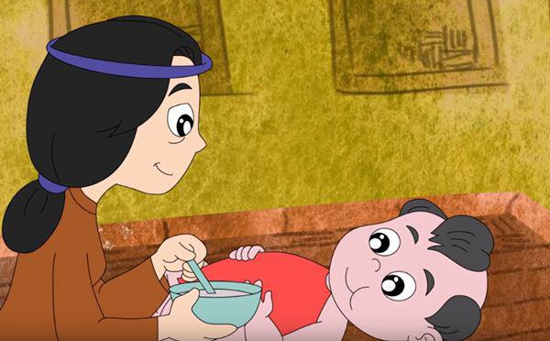

P2
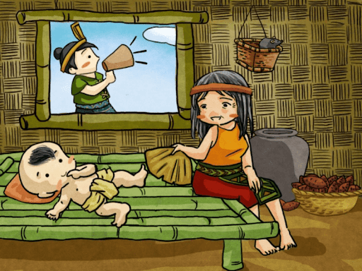
P3
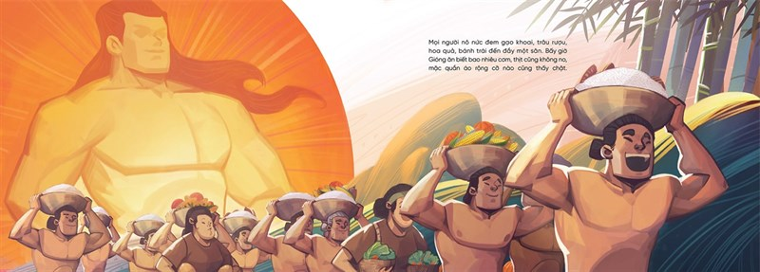

P4
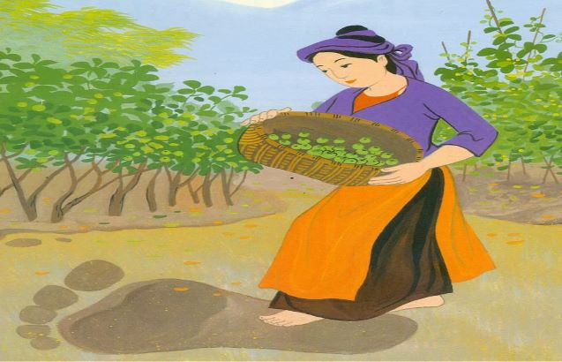
P5
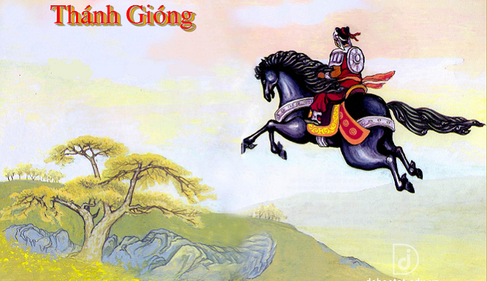

P6
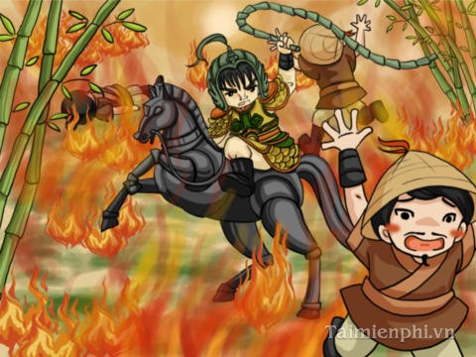

P7
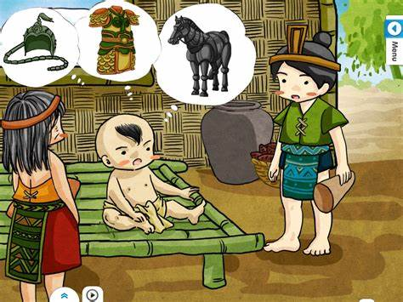

P8
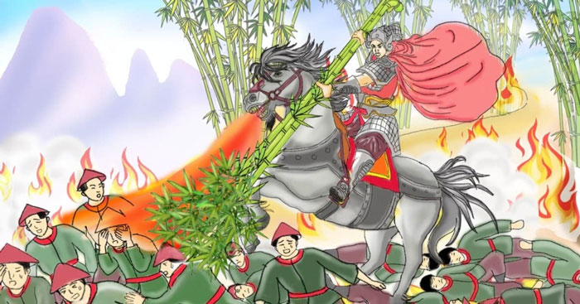
P9
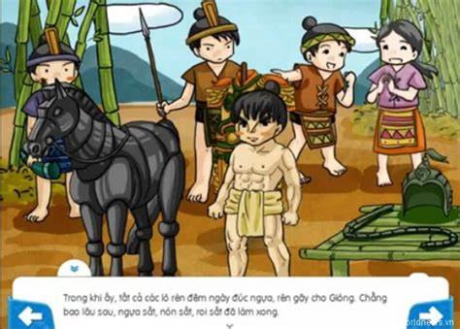
Picture 10
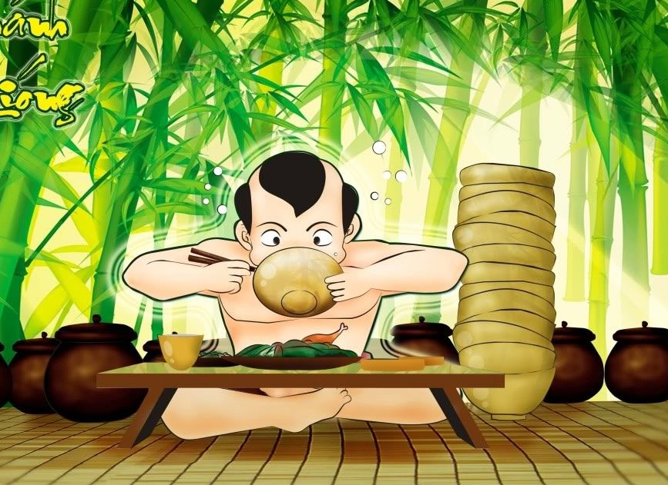

Activity 4
Work in group of six to retell the legend of Saint Giong using the pictures you have just arrange. Every group member should try to practice telling the story.
One upon a time/ A very long time ago under the reign of King Hùng VI, there was an old married couple lived in a small village. They married for a long time but still did not have any children. They wished deeply to have a child. One day................................................................................................................................................................................................................................................................................
Activity 5
Look at the pictures again and rewrite the legend using your own word. Be sure that you use the simple tense. If you have finished rewriting the legend, please swap your paper to another student. Then, proofread or edit (check the content and language) your friend’s paper.

Unit 8. Suggesting places of interest to visit,
Closing a tour
- Suggesting places of interest to visit
Warm- up activity
- List some famous tourist destinations in Vietnam
- Which is the most favoured destination in Vietnam to foreign tourists?

Located in Southeast Asia, Vietnam is a small and beautiful country with victorious history, profound patriotism and wonderful landscapes. Exploring the beauty of the country with its people and culture should be done once in one’s lifetime. There are vast and varied top tourist attractions in Vietnam to discover.
Activity 1
Familiarize yourself with the following beauty places of interest or attractions in your beloved country, Vietnam by matching the photos of the attractionss with the names and the locations.
(.....) Trang An landscape complex
(.....) Ho Chi Minh city
(.....) Nha Trang Beach
(.....) Da Nang city
(......) Ha Long Bay
(......) Hoi An ancient town
(.....) Ha Noi city
(.....) Sapa
(......) Hue imperial city
(.....) Mui Ne

1
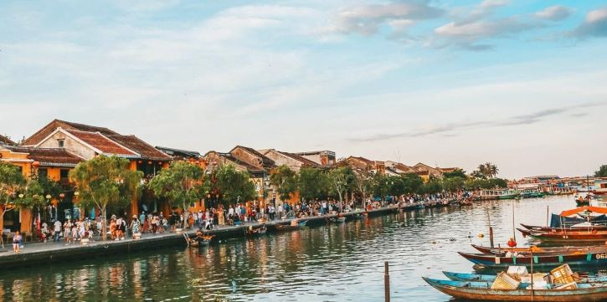

2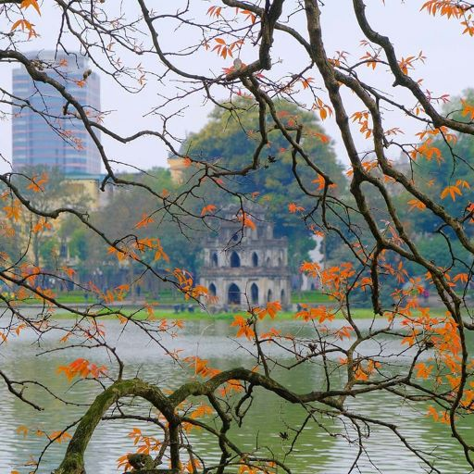

3
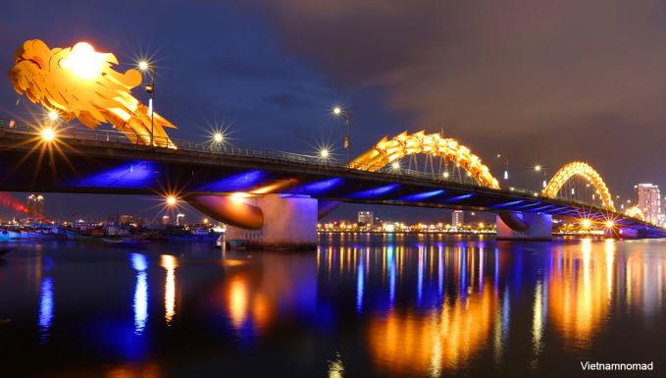

5
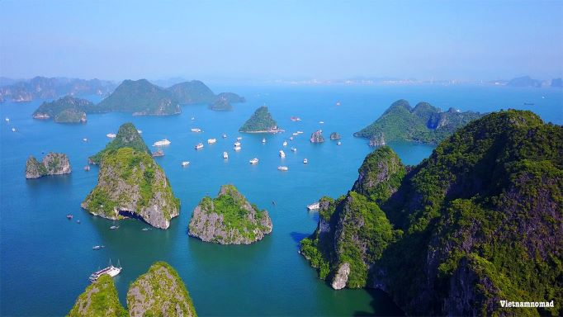

7
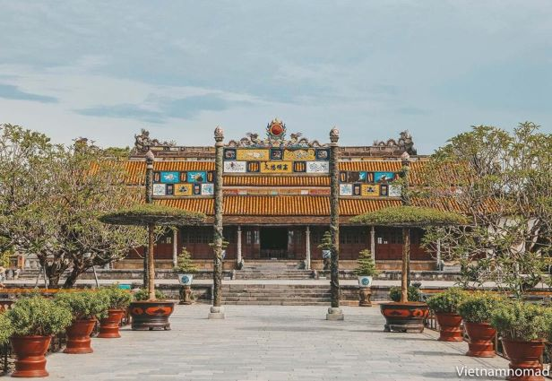

9
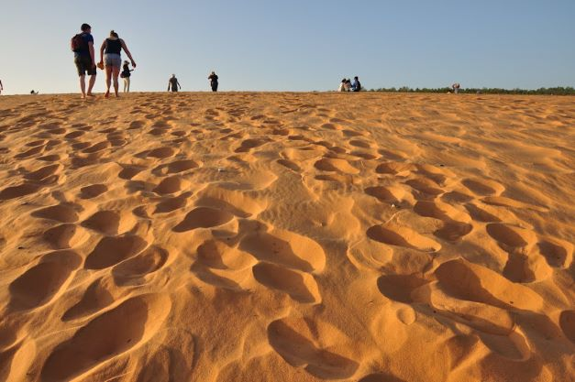

4
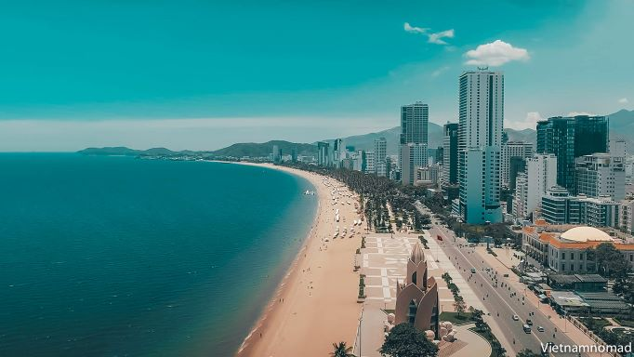

6
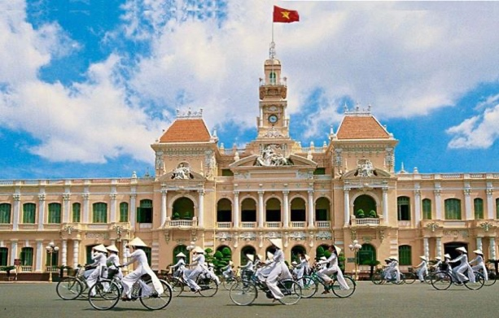

8
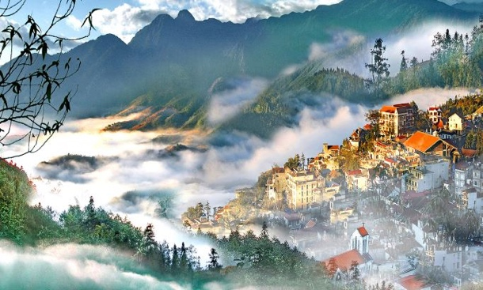
10
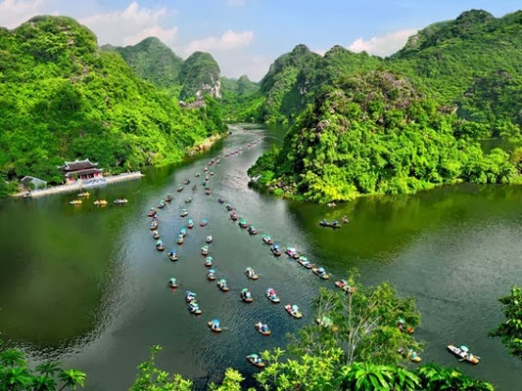

Activity 2
Work in pair. Choose one of the places of interest above that you are familiar with and tell your friend about it in more details such as what we can see, find and enjoy.
Activity 3
Work in group of four. Interview three of your classmate about palaces of interest around your hometown, in Vietnam or abroad which they have visited recently, on one-to-one basis using questionnaire below.
Ask the following question | Classmate’s name
Ask the following question | 1. | 2. | 3.
Which places of interest you have visited lately?
Where is it located?

Whom did you go there with?
How did you go there?
What does the destination offer you?
Describe further what the place is like
What is the most interesting thing there?
Extra information

Activity 4
Work individually to read the following ten best places to visit in Vietnam in 2022 adopted from vietnamnomad.com. Half of the students in class do part A and the other half of them do part B. Feel free to talk to a student having the same part of the passages as yours. Student A(s) reads especially the 1st to 5th best places to visit.

Ten best places to visit in Vietnam
(the 1st to 5th best palaces for student A)
1. Ha Long Bay
Off Northeast Vietnam, Ha Long Bay was designated as one of the World Heritage Sites in 1994. For many reasons, Ha Long Bay has to be on your list when you travel to Vietnam.
Having been known for thousands of limestone islands that emerged from the emerald water, the bay is surrounded by a spectacular seascape. You will want to sign up for a boat trip to cruise along the maze of channels and uniquely shaped islets. You can also go kayaking and caving to experience the enchanting beauty of this wonderland.
Although it can get very touristy during the high season, with what it has to offer, Ha Long Bay is totally worth your visit.
2. Ninh Binh
Used to be one of the hidden gems in the north of Vietnam, Ninh Binh has become more and more popular among both local and foreign visitors after being chosen as the blockbuster Kong’s filming location. But Ninh Binh is not all about that.
This is home of the biggest temple in South East Asia, which is solemnly situated amid the lush paddy fields and breathtaking rock formations. The best way to explore the renowned landscape complex is by rowboat to bit-by-bit take in the majestic and poetic scenery. Ninh Binh will truly give you a sense of the spiritual calmness coming from the splashing water under your boat and distant temple bells echoing.
3. Hoi An
Noted as another World Heritage Site of the long-stretching nation, the Ancient Town of Hoi An carries not only the diversity of settings but also the history of hundreds of years of cultural interference between the three countries of China, Japan, and Vietnam. You will need to be ready to fall in love with the mix of vibrant lifestyle and ancient architecture of this little town.
Hoi An is also famous for a wide range of delightful cafes and restaurants of those overlooking peaceful views. Even for a local, the town’s delicacies are definitely one-of-a-kind, and it will give you a hard time to pick among all the good food.
4. Da Nang
Further north from Hoi An is a beautiful coastal city – Da Nang. Da Nang is a tropical sea paradise in Vietnam; it has some of the most beautiful and secluded beaches such as Non Nuoc Beach, which is almost never too busy. It would make you extend your staying here with its spectacular mountain temples, well-decorated bars and restaurants, and so much more. It is not random that many expats choose to relocate here as you can easily find a hint of the modern lifestyle of a big city blended into the tranquility of the natural surroundings.
If you are an adventurous soul, get on a motorbike and go for a road trip around Son Tra Peninsula, then set out to conquer the Hai Van Pass or simply walk the majestic Golden Bridge.
5. Hue
Hue is the former imperial capital of Vietnam under the prosper reign of the Nguyen Dynasty, which explains for a rich collection of tombs, palaces, and royal buildings. That is also the highlight of this romantic city.
Strolling along the gorgeous Perfume River, crossing Trang Tien Bridge just to later sit down and take a sip of cold Huda beer.
Hue is definitely not a tourism hub but if you are keen on an atmospheric with a breadth of history, then Hue would be your perfect choice.
Fill in the table using information about the 10 best places to visit in Vietnam, especially the 1st to the 5th best ones (vietnamnomad.com)

For student A
Rankings and destinations | Location and how to get there | What tourist can find and enjoy
1. Ha Long bay
2. Ninh Binh
3. Hoi An
4. Da Nang
5. Hue

Activity 5
Work individually to read the following ten best places to visit in Vietnam in 2022 adopted from vietnamnomad.com. Half of the students in class do part A and the other half of them do part B. Feel free to talk to a student having the same part of the passages as yours. Student A(s) reads especially the 1st to 5th best places to visit. Students B(s) reads the 6th to 10th top best places to visit.
6. Sapa
In 6th place, Sapa meets all the elements to become one of the best places to visit in Vietnam: the small villages like the picture painted on the majestic hills, upland markets, and the identity of ethnic minority communities.
Although the main town itself has been said to be too touristic and going through lots of constructions, it gives you a reason to go out of town and immerse yourself in one of the most beautiful highland cities of the country. Meeting up with the innocent local minority people and being amazed by terraced fields – breathtaking scenery will be your unforgettable memory.
7. Nha Trang
As one of the most beautiful beaches in Vietnam, Nha Trang has been recognized as a tropical sea paradise. Not only do long blue beaches and dozens of large and small islands remain untouched, but Nha Trang is also an ideal destination for those who love culture – history as it is also the land of the flourishing Champa Kingdom in the past.
Visit Nha Trang, immerse yourself in the refreshing water, dive down to the coral reefs, discover islands by canoe, and enjoy fresh seafood.
8. Ho Chi Minh city
When talking about the best places to visit in Vietnam, it’s impossible to ignore the biggest city in the country: Ho Chi Minh City.
Ho Chi Minh City (Saigon) is the most developed and somehow chaotic city across the country once known as the Pearl of the Far East. Although Saigon is not rich in natural resources, it has a wide range of street food and nightlife activities to choose from.
And if your heart is up for knowledge, there is a list of museums and galleries scattered around the city so you can check them out and explore the city at the same time.
Chinatown is also the soul of the dynamic city filled with century-aged temples and shops – where you can give yourself a break after play-hard days. It is no exaggeration to say that Saigon has it all.
9. Ha Noi
It is always worth visiting the capital city of any country. In Hanoi, your mind will be blown away with the subtly busy of the Old Quarter – 36 Streets. You will live the historic moments walking along Long Bien Bridge.
You will love every single second riding around Truc Bach Lake and finding yourself a good coffee spot to sit down and enjoy a hot egg coffee. And when the sun goes down, get yourself to the Main Cathedral, sit on those red stools and join the locals for lemon tea and sunflower seeds.
10. Mui Ne
Mui Ne is another coastal city to add to your list. Unlike any other beaches, Mui Ne is the paradise for those into extreme water sports. You can do from snorkeling, diving to surfing and parachuting. Riding past miles of white and red stunning sand hills on one side and feel the ocean breeze blowing from the sea from the other side, you will know why this destination keeps popping up in travel conversations. And of course, live seafood is freshly brought to restaurants from the fishing boats will fulfill your visit.
Mui Ne is not only good for motorbike trips but also the best place across the country for water sports. November to April is the windy season making it perfect for kitesurfing and windsurfing. Other activities such as parasailing, kayaking, and motorboating can also be spotted. Make sure you eat at one of the food stalls set on the beach for the unforgettable dining experience.
Fill in the table using information about the 10 best places to visit in Vietnam, especially the 6st to the 10th best ones (vietnamnomad.com)
For student A
Rankings and destinations | Location and how to get there | What tourist can find and enjoy
6. Sapa
7. Nha Trang
8. Ho Chi Minh city
9. Ha Noi
10. Mui Ne

Activity 6
Work in pair (student A with student B). Student A completes the table of the 6th to 10th best places by asking students B who has the information about those five best places. Student B completes the tables of the 1st to the 5th best places to visit by asking student A who has completed them. They may use or need the following questions to ask their partner.
a. What is the first best place to visit in Vietnam?
b. What is the sixth best places to visit in Vietnam?
c. Where is it located?
d. How can we go there?
e. What does you find there?
f. What can we do or enjoy there?
Activity 7
Identify 5 top attractions in your area. Write each of them in one paragraph like the example of the 10 best places to visit in Vietnam. After checking the contents and language, please tell your friends about those attractions to persuade them to go there
- Closing a tour
Studying the following information about closing a tour
Closing is meant to end the tour. It can be on the way back from a destination to a hotel or before the customers leave for another destination or their home country. It is done either in the bus or dining hall or business meeting room for a normal closing.
A tour closing is very important part of a tour programme. Tour guide does not only summarize the tour, reminding something that impresses them but also thanks customers for joining the tour and apologizes for the inconvenience. Tour organizers can evaluate their product by getting feedback from the customer about the tour, guide, facilities and services by using questionnaire. Feedback is very useful to improve their future programme and services. This is also an opportunities for them to promote and sell the other tour product.
In addition, the customers are reminded not to forget to check their precious belongings such as camera, watch, accessories left in the hotel. After delivering the railway or airline tickets, they are also reminded again their time of departure and wish them a pleasant journey.
Sample
Good evening ladies and gentlemen.
Our one-day tour has just finished. I hope that you all enjoyed our programmes. Anybody still remember the places of interest and attractions to be visited? Yes, Sung Sot cave, Luon Cave or Ti Top Island. Oh great, you still remember them all. Which is the most attractive one? Sung Sot cave. Yes, I agree with you all.
On behalf of Saigon Tourist Company, I would like to thank you for joining our tour. I hope that it becomes a memorable tour. We do apologize for inconveniences you feel or experienced especially for the small accident with the bus. Before we close, we would like to ask your favour to fill in the questionnaire in order to improve our coming programme. If you have finished answering the questionnaire, I’ll give your tickets. Thank you and have a nice journey.

Unit 9. Temple of literature
Part 1: Temple of literature – School for the son of the nation
Brief introduction
Pre-reading questions
- Where is Van Mieu – Quoc Tu Giam?
- When was the Temple of Literature built?
- When was the School for the Sons of the Nation built? Why was it built?
- When was Khue Van Pavilion built?
- What are the precious relics in this vestiges area? When was the first stelea to the doctor laureate erected in the Temple of Literature?When was the first stetea to the doctor laureate erected in the Temple of Literature?
Reading
In the heart of Hanoi, amist the bustling streets of the capital city of modern – day Vietnam, stands Van Mieu – Quoc Tu Giam (the Temple of Literature), a quiet place where scholars come to read, artists come to paint, and travelers come to seek traces of nearly a thousand years of Vietnamese culture and history. The Temple of Literature is a complex of Temple and former school for the sons of the nation. The Temple was set up in 1070 AD under the Ly Dynasty dedicated to Confucius and Chu Cong, a member of the Chinese royal family in the 11th century BC who invented the teaching developed by Confucius 500 years later.
Quoc Tu Giam (“School for the Sons of the Nation”) was set up six years later becoming the first university of Vietnam. At first, the university was only open to members of royal famillies but it later amitted talent students who had passed the provincial examinations or composed a great work.
For 700 years, until the Nguyen dynasty moved the capital and the university to Hue, the school fostered some of Vietnam’s greatest statesmen and men of letters, men like Nguyen Trai and Chu Van An, who are honored to this day.
In 1484 the Van Mieu – Quoc Tu Giam came to memorialize the most brilliant scholars of the nation, when King Le Thanh Tong erected stelae inscribed with the names of those whose attained the rank of doctor laureate in the national examinations. Over the centuries, war and social change have altered some features of the Van Mieu. Most notably, the first two courtyard and the Khue Van pavillion were added in the early 19th century. In 1947, the remainings in the fifth courtyard were destroyed by shelling.
The Van Mieu in its present form is modeled after the Temple of Confucius at Quyfu, China, with the five courtyards representing the five essential elements of nature. Five courtyards seperated by brick walls now make up the interior. In Confucianism, as in Buddhism, the number five has a special place. There are five essential elements, five basic virtues, five commandments, five sorrows, five carfinal relationships, and five classics.
A central pathway divides the complex into symmetrical halves as it leads the visitor through the diferent courtyards to the temple altar. Each courtyard is connected to the next by three paralled gates, or doors, that bear names bymbolic of advancing in wisdom. Couplets, contrasting and complementary in meaning, while parallel in structure and harmonious in sound, are inscribed in Chinese characters on the side columns of the gates.
The balance and contrasting elements within the unity of the larger whole is a theme reflected in much of the temple’s design. It is a theme common to Confucianism, Taoism and Buddhism, three deep currents of Vietnamese tradditional and modern life.
Today it is a shrine to brilliant scholars of the past, a place where the occasional student sitll comes to study and pray for good luck in the exams and repository of nine centuries of Vietnamese history.
Vocabulary
Words and phrases to remember
Temple of Confucius Confucius
Confucianism Taoism
To be modeled after contrasting elements
A comlex of temple the interior
Courtyard Khue Van pavillion
The temple altar symmetrical halves
Seek traces of dedicated to
Men of letters erected stelae
Five classics five basic virtues
Five commandments five sorrow
The five essential elements five cardinal relationships
The Temple of Literature School for the Sons of the Nation
Three parallel gates/doors the side columns of the gate
The national examination provincial examination
Compose a great work the rank of doctor lauraete
Vietnam’s greatest statesmen members of royal families
Exercises
- Match each word or phrases in the column at the left with its meaning in the column on the right.
1. mandarin a. Chinese philosopher, who taught the need for high moral standards, esp. Goodness, justice, loyalty and respect for parents and ancestors.
2. entrance b. member of the aristocracy; nobleman or noble woman
3. Taoism c. help the growth or development of (sth); encourage or promote
4. courtyard d. person who plays an important part in the management of state affairs, esp. one who is skilled and fair, wise political leader
5. represent e. two successive lines of verse of equal lenghth
6. statesmen f. unproofed space partially or completely enclosed by walls or buildings e.g. in a castle
7. couplet g. stand for or be a symbol or equivalent of (sb/sth)
8. sorrow h. place where things are stored or may be found, esp. a ware – house or museum
9. ethic i. group of connected or similar things
10. foster k. Chinese religious and phylosophical system which teaches that one should act in harmony with nature
11. Confucius l. high-ranking goverment official of China
12. aristocrat m. opening, door, gate, passage, etc by which one enters sth
13. repository n. feeling of sadness or distress caused esp. by loss, disappointment or regreet
14. complex o. system of moral of principle; rules conduct
15. inscribe p. Chinese philosophical and ethic system based on the teaching of Confucius
16. symmetrical q. general rule, standard or principle by which sth is judge
17. Confucianism r. write (words, one’s name, etc) on or in sth; esp. as a formal or permanent record
18. canon o. (of a design, etc) having two halves which are the same in size and shape.
II. Context clues
1. In the heart of Hanoi, amist the bustling streets of the capital city of modern – day Vietnam, stands Van Mieu – Quoc Tu Giam (the Temple of Literature), a quiet place where scholars come to read, artists come to paint, and travelers come to seek traces of nearly a thousand years of Vietnamese culture and history.
- streets are full of noise, activity, etc
- streets are full of sound, dust, etc
- streets are full of litter, dust, etc
- streets are full people, animal, etc
2. The Temple was set up in 1070 AD under the Ly Dynasty dedicated to Confucius and Chu Cong.
- reconstructed b. created
c. made d. established
3. At first, the university was only open to members of royal famillies but it later amitted talent students who had passed the provincial examinations or composed a great work.
a. thi hoi; listened to b. thi hoi; wrote
c. thi đinh; spoke d. thi huong, read
4. For 700 years, until the Nguyen dynasty moved the capital and the university to Hue, the school fostered some of Vietnam’s greatest statesmen and men of letters, men like Nguyen Trai and Chu Van An, who are honored to this day.
a. permitted b. discourage
c. promoted d. pushed
5. In 1484 the Van Mieu – Quoc Tu Giam came to memorialize the most brilliant scholars of the nation, when King Le Thanh Tong erected stelae inscribed with the names of those whose attained the rank of doctor laureate in the national examinations.
a. made, accomplished b. set up; achieve
c. manufactured; acquired d. produced; procure
6. Over the centuries, war and social change have altered some features of the Van Mieu.
a. replaced b. modified
c. change d. added
7. Most notably, the first two courtyard and the Khue Van pavillion were added in the early 19th century.
a. building b. storey
c. construction d. portal
8. Five courtyards seperated by brick walls now make up the interior.
a. inside b. center
c. bore d. internal
9. There are five essential elements, five basic virtues, five commandments, five sorrows, five carfinal relationships, and five classics.
a. compassion; chief b. pity; essential
c. sympathy; important d. grief; fundamental
10. It is a theme common to Confucianism, Taoism and Buddhism, three deep currents of Vietnamese tradditional and modern life.
a. main religion b. main lines
c. main roads d. main streams
Using English
Verb forms
Rewrite each sentence, selecting the corect form of a verb from those in parentheses
- In 1070, Vietnamese people (built, were built, had built) the temple of literature (worshipping, to worship, worshipped) Confucius and Chu Cong.
- Talent students who (passed, had passed, were passed) the provincial examninations (admitted, had admitted, were admitted) (studying, to study, study) at the School for the Sons of the nation.
- In 1484, King Le Thanh Tong (orders, had ordered, ordered) the erection of stelae (to memorialize, memorializing, memorialized) the most brilliant scholars of the nation.
- Some features of the Van Mieu (have been altered, have altered, are altering) because of war and social change.
- In the early 19th century, Khue Van Pavillion (were built, built, was built).
- In 1947, French shelling (had destroyed, were destroyed, destroyed) the remaining buildings in the fifth courtyard.
- Education at Quoc Tu Giam (preparing, to prepare, prepared) students for the Royal examination, the gateway to (became, becoming, became) a scholar mandarin and (serve, serving, served) at the court or in high position in the province.
- The new mandarins (were offered, had offered, offered) a hat and grown, (giving, gave, given) a banquet at the palace, and (sending, send, sent) home to their villages in triumphral procession.
- The Royal examinations (should have been held, may have been held, might be held) on the side of what is now the National library, as (suggesting, suggest, suggested) by some historian and by the street name, Trang Thi, or Examination Street.
- Although, there (be, are, is) some dispute over the date, it popularly (accepts, accepted, is accpeted) what (is known, knew, knows) today as the Van Mieu (was established, established, establishes) first in forms in 1070 AD, under Ly Dynasty.
Speaking
Group work
Work in groups of 7 students
It is impossible to talk about everything at the Temple of Literature and School for the Sons of the Nation during the lesson so each student must choose what you think is the most interesting. Each student must talk about at least 2 of the following elements:
+ Van lake
+ dismount stele and four high pillars
+ Great Portico
+ 1st courtyard
+ 2nd courtyard
+ 3rd courtyard
+ 4th courtyard
+ 5th courtyard
Monologue
Talk about the Royal Examinations
Include the following elements:
- The place where the Royal Examinations had been held
- The number of Royal Examinations held in Hanoi
- The interval between Royal Examinations
- The multi – stage examnination process (from the first step, regional examinations to the last, palace examinations)
- The youngest doctor laureate
- The oldest doctor laureate
Writing
Planning your commentary
+ Introduce new information, not only what is in guidebooks (No need for tour guides if tourists have read it in a book already)
+ Use many diferent types of information to appeal to diferent types of tourists (cognitive; sensory; emotional)
Topic: Give an introduction to the Temple of Literature
Consider these aspects:
- Location
- The history of this site (what is it, when was it established, its origins)
- Architect
- Royal examninations
- Confucianism

Unit 10. Temple of literature – School for the sons of the nation
Part II. Temple of literature – School for the sons of the nation
Architecture
Pre-reading questions
- What do know about the Lake of Literature in front of Van Mieu – Quoc Tu Giam?
- In the past, before entering the first gate, what did people often do to show respect?
- What do you know about Van Mieu – Quoc Tu Giam in the 17th century?
- What was the meaning of the dragon images?
- What was the meaning of the tiger images?
Reading
Temple of Literature Hanoi
The historical site of the Van Mieu –Quoc Tu Giam covers an area of 55207 square meters including the Lake of Literature, Giam Park, and the interior courtyards surrounded by the brick “Vo” wall. In front of the Great Portico, there are four high pillar. On either side of the pillars are two stelae commanding horsemen to dismount.
The Van Mieu is built in the shape of a parallelogram, modelled after the Temple to Confucius in Qufu, China.
The interior of the site is divided into five courtyards.
The first courtyard (Entrance to the way)
The first court yard extends from the Great Portico to the Great Middle gate, which is flanked by two small gates: Attained Talent and Accomplished Virtue. The central path is straight, the symmetry of both halves reflecting the balance and harmony of livfe lived according to the Confucian Middle Path, or Golden Mean. The way is graced by lotus ponds and sacred trees like the banyan and frangipani. Two carp perch atop the Great Middle Gate, making obeisance to a flask of nectar from heaven, a flask of nectar to Confucianism. These carp symbolize students, on their way to become mandarins.
The second courtyard (Success)
The second courtyard stretches from the Great Middle Gate to the Khue Van Pavilion. The pavilion, built in 1805, is a symbol of Hanoi’s cultural history. It is rich in the complimentary symbolism of yin-yang. There is high and low, wind and water, sky and earth. The brick platform is square, the symbolic shape for earth, sky is present in the wooden superstructure adorned with four circular suns, outlined in wood, that radiate their light to the four directions. Dragons crown the roof, making obeisance to the moon.
To the sided of the Khue Van Pavilion are Suc Van gate (gate of the Crystallization of Letters) and Bi Van gate (gate of the Magnificence of letters)
The third courtyard (stelae courtyard)
At the center of the third courtyard is a square pond called Thien Quang Tinh, or Well of Heavenly Clarity. There are two chains of stelae pavilion housing 82 doctors’ stelae on the two sides of the well. On each side of the pond, between the double rows stelae, stands a small shrine where incense is burned to honor the memory of the laureates. The oldest stele stands in the shrine on the entering visitor’s right. Behind them, leading to the fourth courtyard is the Dai Thanh gate, flanked by 2 smaller gates, Kim Thanh and Ngoc Chan.
The fourth courtyard (Sage Courtyard)
On the right and left of the ceremonial court stand 2 houses originally used to house the altars to the 72 most honoured disciples of Confucius and Chu Van An.
In the center is the Bai Duong (House for ceremonies) where ceremonies took place in festival time. The building, standing on two walls supported by nine pillars, is crowned by jubilant dragons making obeisance to the moon. The altar occupied the open center. Cranes perched atop tortoises on either side of the altar may be taken as symbols of the union of heaven and earth. The eight wooden standards represent the eight weapons of the scholar mandarins. Behind it is Dai Thanh sanctuary, where are worshipped Confucius and his 4 closet disciples: Yunhui, Zenghshen, Zici, and Mencius. The sanctuary houses as well as altars to 10 honored philosophers.
The fifth courtyard
The fifth courtyard destroyed by war in 1946 is for the Thai Hoc buildings, originally the first National College. In the 19th century the Kim Thanh shrine, dedicated to Confucius’s parents, was built on the former ground of the Quoc Tu Giam. The Thai Hoc buildings were constructed in 1999 and finished in 2000 to honor traditional culture, celebrate 1000th anniversary of Thang Long foundation and dedicate to great national scholars.
The designs of the Thai Hoc courtyard were based on traditional architecture in harmony with harmony with the surrounding sights of the Temple of Literature. The courtyard consists of four buildings (front hall, back hall, left wing, right wing) and two pavilion one for bronze bell and the other for large drum. The main materials for their construction were ironwood, shoe-like tiles and brick.
Vocabulary
Words and phrases to remember
The Great Portico four high pillar
Entrance to the way Great Middle Gate
Attained talent Accomplished Virtue
Success Sage Courtyard
Confucian Middle Path Golden Mean
Stelea pavilion the ceremonial court
The wooden superstructure house for ceremonies
The symmetry of sacred tree
Banyan yin-yang
Frangipani carp
Crane tortoise
The eight weapons circular sun
Incense doctors’ stelae
Mandarin philosopher
Most honor disciple of closet disciple
Perch atop crown the roof
Make obeisance to dismount
The union of heaven and earth a flask of nectar from heaven
The eight wooden standards well of heavenly clarity
Gate of Crystallization of letters gate of Magnificence of letters
In the shape of
Exercises
- Match each word or phrase in the column at the left with its meaning in the column on the right.
1. yang | a. roof supported by column, esp. one forming an entrance to a large building
2. ceremony | b. upright column of stone, wood, metal, etc used as a support or an ornament, a monument, etc.
3. superstructure | c. (in Chinese philosophy) the active bright male principle of the universe.
4. portico | d. (in Chinese philosophy) the passive dark female principle of the universe
5. accomplished | e. Formal act or series of formal acts performed on a religious or public occasion
6. yin | f. structure built on top of sth else, e.g. the part of a building above the ground
7. symmetry | g. well trained or educated in social skills such as conversation, art, music, etc.
8. pillar | h. exact match in size and shape between the two halves of something
9. incense | i. condition that exists when 2 opposites are equal or in correct proportions
10. carp | k. pleasing combination of related things
11. harmony | l. Indian fig-tree whose branches come down to the ground and take root
12. disciple | m. (smoke from a) substance that produces a pleasant smell when burned, used esp. in religious ceremonies)
13. flask | n. type of large edible and fresh water fish that lives in lakes and ponds
14. crown | o. follower of a religious, political, artistic, etc leader or teacher
15. jubilant | p. bottles with a narrow neck for storing oil, wine etc
16. banyan | q. form or cover the top of sth
17. balance | r. showing great happiness, esp. because of a success
- Context clues
1. The interior of the site is divided into five courtyards
a. areas b. courts
c. yards d. components
2. On either side of the pillars are two stelae commanding horsemen to dismount
a. take off b. come down
c. get out d. get off
3. Two carp perch atop the Great Middle Gate, making obeisance to a flask of nectar from heaven, a flask of nectar to Confucianism.
a. giving regards to b. paying homage to
c. paying regard to d. doing the honor
4. Two carp perch atop the Great Middle Gate, making obeisance to a flask of nectar from heaven, a flask of nectar to Confucianism.
a. a flask of rain-water b. a heaven-sent flask of nectar
c. wine gourd d. wine bottle
5. The brick platform is square, the symbolic shape for earth, sky is present in the wooden superstructure adorned with four circular suns, outlined in wood, that radiate their light to the four directions.
a. decorated b. exaggerated
c. enriched d. refined
6. Dragon crown the roof, making obeisance to the moon.
a. lie b. cover
c. occupy d. settle
7. The altar occupies the open center.
a. is built b. is constructed
c. is erected d. is placed
8. Cranes perched atop tortoises on either side of the altar may be taken as symbols of the union of heaven and earth.
a. agreement b. accordance
c. communion d. harmony
9. In the center is the Bai Duong (House of ceremonies) where ceremonies took place in the festival time.
a. observances b. celebrations
c. rites d. pageants
10. The Thai Hoc building were constructed in 1999 and finished in 2000 to honor traditional culture, celebrate 1000th anniversary of Thang Long foundation and dedicate to great national scholars
a. were designed b. were erected
c. were modelled d. were built
Using English
Inversion
When an adverbial expression of place or direction comes at the beginning of a clause, intransitive verbs often put before their subject. This happens especially when a new indefinite subject is being introduced. The structure is most common in literary and descriptive writing.
In the center of the room stood a big man with grey beard.
Near the school was an old house.
This structure is often used in speech with herem there and other short adverb particles
Here is the man you want to meet.
There is Long Bien Bridge.
Off we go!
Underline the adverbial expressions of place or direction that come at the beginning of the following sentences:
- On either side of the pillars are two stelae commanding horsemen to dismount.
- To the sides of Khue Van are Suc Van gate (gate of Crystallization of Letters) and Bi Van gate (gate of Magnificence of letters).
- At the center of the third courtyard is a square pound called Thien Quang Tinh, or Well of Heavenly Clarity.
- On each side of the pond, between the double rows stelae, stands a small shrine where incense is burned to honor the memory of the laureates.
- Behind them, leading to the fourth courtyard is the Dai Thanh gate, flanked by 2 smaller gates, Kim Thanh and Ngoc Chan.
- On the right and left of the ceremonial court stand 2 houses originally used to house the altars of 72 most honoured disciples of Confucius and Chu Van An.
- In the center is Bai Duong (House for ceremonies) where ceremonies took place in festival time.
- Behind it is Dai Thanh sanctuary, where worshipped Confucius and his 4 closet disciples: Yunhui, Zengshen, Zici and Mecius.
- The temple was built around the beginning of the Christian era. Here came the first India missionaries to Vietnam.
- Directly in front of them stood an old temple.
Speaking
Group work
Each student will make a presentation of the content they have prepared on the temple. Other acts as tourists and make questions for the guide to answer.
(Take it in turn to act as a tour guide in Van Mieu – Quoc Tu Giam)
Monologue
Talk about the Doctor’s stelae in Van Mieu – Quoc Tu Giam
Include the following elements
- The number of the doctors’ stelae
- The oldest doctors’ stelae
- Types of the doctors’ stelae
- Preservation of the doctors’ stelae.
Writing
Each students must prepare a full tour commentary about Van Mieu – Quoc Tu Giam
Include the following elements:
- Full introduction of self and tour
- Site and subject introduction
- Information about the history of this site
- The Great Portico
- First Courtyard
- Second courtyard ( Also talk about Khue Van pavilion)
- Third courtyard (Garden of the stelae and the preservation of the stone stelae)
- Fourth courtyard (Also talk about the Confucianism)
- Fifth courtyard: Thai Hoc courtyard ( Quoc Tu Giam; The royal examination; Thai Hoc building)

Unit 11: My Son Sanctuary
Pre-reading questions
1. Where is My Son holy land?
2. Why were monuments of the Chams left ruined and forgotten for a long time?
3. What is a temple-tower?
4. Which deities are worshipped in My Son temple?
5. When was My Son Holly Land recognised as World Cultural Heritage?
Reading
Temple – Towers in My Son
Most principle temples in My Son were built to worship God Shiva under different title. With about 70 architectural monuments built from the 7th century to the 13th century, My Son was the most important Hinduist Sanctuary of Champa Kingdom here we can find almost architectural styles in Cham art.
Champa temple-towers which remain till now were mainly built of brick, sandstone for making door support, lintel, maintaining or decorating tower foundation, body and top of towers. The thickness of the walls are from 80 centimetres to over 160 centimetres. Perhaps, this is one of the reasons making Champa temple-towers remain in many centuries. Brick used for building tower had different sizes, the smallest is about 12 cm x 8 cm x 4 cm, the biggest is about 40 cm x 16 cm x 8 cm. It was rather hard but porous, its gross weight is about 1.522 grammes/cm3 (meanwhile present brick is about 1.8 grammes/cm3) with high percentage of absorbent.
The brick in the outer wall had smoothly been ground before building so it made good attached surface and need only very thin layer of mortar to fix the brick together. At first glance, it looks as if there was no layer of mortar, but in the middle of the wall, mortar was used thickly, somewhere there was even broken brick mixed with mortar.
The tower foundation was often maintained as follows: there was a bed of raw sand at the bottom about 10 centimetres thick, next a layer of pebble or grave about 15 -20 centimetres thick, then a bed of sand about 10 centimetres thick, the above is a bed of laterite, the size of each stone is 20 x 40 centimetres.
Temple- towers in My Son were arranged in general:
- The Main Temple (Kalan), located in the centre, symbolizes Meru mountain in Hindu concept. It is the centre of universe, where Gods gather, ordinarily there is a door facing east and west.
Gate tower (Gopura), located right in front of Kalan, has 2 communicative doors facing east and west.
Mandapa (a long house linked with the gate tower) where pilgrims and offerings were received…
Next to the main temple, there was a tower with one or two rooms. The door faced north. It was used for holding praying clothes called Kosagraha.
- Besides, there were subordinate towers around Kalan of worshipping Gods of direction (Dikpalakas), Gods of Planets (Grahas) or Minor Gods such as Skanda, Ganesa, etc.
A traditional Cham tower has 3 parts:
- The foundation (Bhurloka): Having square of rectangle surface constructed by brick of huge stone. It symbolized the world of human beings.
- The body (Bhurvaloka): built of brick, door supports made of sandstone with stone lintel. In the walls and pillars carved decorative motifs or images of people and animals. It symbolizes the world of spirit, where people purified themselves could in touch with Gods and ancestors.
- The roof (Svarloka): Having 3 storeys, smaller in the upper. The above is the smaller image of the below, on top is a sharp sandstone summit, decorated by lotus petals. It symbolizes the world of divinities.
My Son is not only known for its architectural monuments, but also famous for hundreds of priceless sculptural objects, which date from the 7th century to the 13th century. Cham sculptural art was the selective and creative combination autochthonal elements and foreign cultures.
Although sculptural works skilfully changed rough stones into lively and soulful masterpieces. Each art style has its own beauty because sense of beauty always changed through time.
Most architectural works found in the early years of the 20th century were displayed in Da Nang Museum of Cham sculpture.
From 1937 to 1944, the Ecole francais d’Extreme Orient restored the towers belonging to the group A, A’, B, C and D. In 1939, a dam was built to change current of a stream which damage A9 tower The dam was completed in 1944, but it was tragically damaged by a big flood in 1946.
According to the count – up of the French before 1946, there were about 50 fairly intact monuments in My Son. But after the two wars, especially in 1969, with U.S . Air Force bombardment. My Son relics were wholly broken down, including the famous A1 temple.
After 1975, about 20 towers were still in shape but not intact. In service of the inventory, investigation and restoration of the relics, a work of clearing –tip and neutralizing bombs and mines was carried out in 1978, causing eleven injured and six dead for the peacefulness of this land.
Since 1980, the Vietnamese-Poland cultural co-operation programme had been carried out, under the direct technical guidance of Mr. Kazimierz Kwiatkowski, a Polish architect.
After 10 years of maintaining and restoring, the best architectural centre of Cham art finally revived. My Son partly regained its initial appearance, so we imagine a monumental and magnetic Hinduist sanctuary of the ancient of Champa Kingdom. Nowadays, a lot of valuable architectural works have been found and displayed in My Son. My Son relic has been inscribed by UNESCO in the list of world heritage on December 01.1999.
Note:
Depending on the position of tower groups, H. Parmetier – an architect and archaeologist who came to study about architecture and art in 1901 – used Latin words to name the towers:
- Group A and A’ (also called Pagoda tower by the local) consist of 17 works.
- Group B, C, D (Market tower) consist of 27 works
- Group E, F (Hố Khế tower) consist of 5 works
- Group H (Chess tower) consists of 4 works
- Group K consists of 2 works
- Different works: L, M, N.
This naming was only conventionally used to distinguish towers for studying. It had no meaning about date.
Vocabulary
Words and phrases to remember
Kingdom sandstone
Lintel porous
Gross weigh absorbent
Layer of mortar a bed of pebble
Gravel laterite
Magnetic pilgrim
Offerings praying clothes
Purified summit
Autochthonal element divinity
Soulful masterpiece sense of beauty
Tragically count –up
Bombardment inventory
Investigation clearing-tip
Neutralize regain
Communicative doors
Exercises
1. Match each word or phrase in the column at the left with its meaning in the column on the right.
1. mortar | a. rock formed of compressed sand
2. grind | b. horizontal piece of wood or stone over a door or window, forming part of the frame.
3. sandstone | c. allowing liquid or air to pass through, esp. slowly
4. laterite | d. polish or sharpen sth by rubbing it on or with a rough hard surface
5. pilgrim | e. mixture of lime or cement, sand and water, used to hold bricks, stones, etc together in building
6. porous | f. small stones, as used to make the surface of road and path
7. lintel | g. type of red soil occurring in tropical regions and widely used there for making roads.
8. purify oneself | h. person who travels to a holy place as an act of religious devotion
9. ancestor | i. make oneself pure by removing one’s sins, esp. in a religious ceremony
10. masterpiece | k. any of the people from whom sb is descended, esp. those more remote than his grandparents; forefather
11. revive | l. task done with great skill, esp. an artist’s greatest work
12. gravel | m. appreciation or understanding of the value or worth of sth
13. sense of sth | n. find out and examine (all the facts about st) in order to obtain the truth
14. neutralize | o. take away the effect or special quality of (sth) by using sth with the opposite effect or quality
15. pebble | p. come or bring (sth) back into use, activity, fashion, ect
16. regain | q. get (sth) back again after losing it
17. investigation | r. having a powerful attraction
18. magnetic | s. small stone made smooth and round by the action of water, e.g. in a stream or on the seashore.

II. Context clues
1. Most principle temples in My Son were built to worship God Shiva under different title.
a. well known b. main
c. famous d. important
2. With about 70 architectural monuments built from the 7th century to the 13th century, My Son was the most important Hinduist Sanctuary of Champa Kingdom here we can find almost architectural styles in Cham art.
a. altar b. adytum
c. church d. temple-tower
3. The brick in the outer wall had smoothly been ground before building so it made good attached surface and need only very thin layer of mortar to fix the brick together.
a. added b. detached
c. fastened d. connected
4. At first glance, it looks as if there was no layer of mortar, but in the middle of the wall, mortar was used thickly, somewhere there was even broken brick mixed with mortar.
a. at first sight b. at the beginning
c. for the first time d. first of all
5. The tower foundation was often maintained as follows: there was a bed of raw sand at the bottom about 10 centimetres thick, next a layer of pebble or grave about 15 -20 centimetres thick, then a bed of sand about 10 centimetres thick, the above is a bed of laterite, the size of each stone is 20 x 40 centimetres.
a. a resting room of b. a mine of
c. a class d. a layer of
6. Gate tower (Gopura), located right in front of Kalan, has 2 communicative doors facing east and west.
a. doors used for the communicative purpose
b. doors used for displaying advertisement
c. communicating doors
d. two doors used as hoarding
7. The roof (Svarloka): Having 3 storeys, smaller in the upper. The above is the smaller image of the below, on top is a sharp sandstone summit, decorated by lotus petals. It symbolizes the world of divinities.
a. quality of being diviner b. god or goddess
c. theology d. Buddha
8. Cham sculptural art was the selective and creative combination autochthonal elements and foreign cultures.
a. native elements b. original elements
c. basic elements d. essential elements
9. Although sculptural works skilfully changed rough stones into lively and soulful masterpieces.
a. showing deep feeling b. mystical
c. meaningful d. expressive
10. According to the count – up of the French before 1946, there were about 50 fairly intact monuments in My Son.
a. calculation b. valuation
c. statistic d. estimation
Using English
Relative clause
- Read the text again to find out the complex sentences that have relative clauses.
- In each of the following sentences there is one mistake. Find out and correct it.
- My Son lies in a luxuriant valley about 2 km in diameter, which surrounded by earthy and rocky hills.
- Through commercial relations with India, the Champa civilisation became profoundly influenced by Hinduism was evidently left in their architectural constructions.
- In the fifteenth century, which the Chams spread southward, the monuments were abandoned, quickly covered by dense forests, left ruined and forgotten.
- And not until 1898 that they were “discovered” by M.C Paris, who a well-known French scholar.
- According to the 31 inscriptions carved on stones, among they, 16 were with precise dates, the first building on the side were erected in the late fourth century by King Bhadra Varmam II.
- Henri Parmentier, is another famous French archaeologist, found out 71 structures of the monument that he conducted being built between the seventh and fourteen century.ry
- The temple were dedicated to Cham kings, combined with Shiva. Who was regarded the founder and protector of the kingdom, and other Cham’s gods.
- The ornamentation on its walls shows also the influence of MalayoPolynesian and Cham decorative style is very distinct from those found in other South – East Asia cultures as well.
- The 24 – meter high A1 and E4, is covered the most beautiful monuments of its kind in Asia, were destroyed and turned collapsed brick walls.
- Quang Nam was once the minor state Amaravati of the Kingdom of Champa, which such famous relics as the My Son sanctuary, the capital Tra Kieu, Don Duong Buddhist monastery and groups of tower were built.
Speaking
Group work
As a tour guide, you will face new challenged every day. One of the hardest part of your jobs may be answering questions. Unlike a speech that you can memorize, you won’t always know what questions people will ask. However, you can anticipate certain types of questions and certain ways that questions will be asked.
Practice
+ using variety when you answer questions or respond to comments
+ politely explaining that you don’t understand a question
Monologue
Talk about Cham relics in Quang Nam
Include the following elements
- Site and subject introduction
- Some background on the Kingdom of Champa
- My Son Holy land
+ history
+ ruined forgotten monuments
+ temple –tower architecture
+ the arrangement of temple –tower
+ restoration plans

Writing
Topic: Give brief introduction to My Son World Cultural Heritage Site
Include the following elements:
- Site and subject introduction
- Some background on the Kingdom of Champa
- General information about:
+ ruined and forgotten monuments
+ the complex of temple-tower
+ the values
+ any restoration plans

Unit 12: Hue royal city
Pre-reading questions
- How long had the citadel city of Hue been built? When did the construction start?
- Speak about the three perimeters of rampart?
- What do you know about Thai Hoa Palace?
- Name as many ancient monuments of Hue as you can?
- Have you ever visited Hue? What make a strong impression on you?
Hue royal city
Its construction started in 1805 under the reign of King Gia Long and was completed in 1832 under the reign of King Minh Mang. The city was built on the northern bank of the Perfume River.
As far as the architecture is concerned, the Imperial city was built by French architect Vauban. The city has three perimeters of rampart: The Defensive Fort (the Royal citadel), the Imperial Enclosure and the Forbidden Purple City.
The Defensive Fort, the outermost boundary has a perimeter of 9,950 m, a thick of 21 m, with 10 gates open to road travellers and two gates for water routes and 24 forts.
The Imperial Enclosure is the second rampart with a perimeter of 2,450. It is accessible through four gates: Ngo Mon (Noon Gate) to the South, Hoa Binh (Peace) to the north, Hien Nhon to the east, and Chuong Duc to the west. Ngo Mon is the main entrance gate of the royal city. Formerly, it was reserved only for the passage of the kings. This is among the few ancient infrastructures that have remained almost intact.
Forbidden Purple City, the third and innermost fort of the royal complex has a perimeter of 1,225 m. Accessible through seven gates, it was the place reserved for the private life of the kings and their families. Forbidden Purple City was almost isolated from the outside world.
Inside the three high rampart and deep moats are located a large cluster of smaller constructions built along the main axis running from south to north. The southernmost structure is Ky Dai (Flag Tower), followed by Ngo Mon Gate, Dai Trieu Nghi Yard, Thai Hoa palace, Can Chanh Palace, Khon Thai, Kien Trung Palace and the last structure is Hoa Binh Gate.
Ngo Mon (Noon Gate) – This three stoey structure is 58m long, 27.5m wide and 17m high and served as the main entrance to the Imperial City. There are five gates to Ngo Mon with the central gate being served for the king only. The two adjacent gates on both sides of the central gate are exclusively for court officials. The other two outer gates are used for servants and members of the royal entourages. On top of the arch is Five Phoenix Tower, which was formerly the place where the king was seated in festive occasion. This was also the place where ceremonies were organised to announce the names of laureate candidates from royal examinations before those names were put on the notice board hanged on Phu Van Lau (Phu Van Tower). During Nguyen King’s reign, Ngo Mon Gate was opened only when the king passing by or receiving foreign ambassadors.
Thai Hoa Palace (Palace of Supreme Peace) was used for the king’s official receptions and other important court ceremonies such as anniversaries and coronations.
The Mieu was one of the shrines and temples dedicated to the kings and royal member of the Nguyen Dynasty. Within Hoang Thanh, there are five temples: Trieu Mieu; Hung Mieu; The Mieu; Thai Mieu and Dien Phung Tien.
The Nine Dynastic Urns were cast between 1835 and 1837 and weigh between 1,600 and 2,600kg each. The cast of the nine urns cost up to 20 tons of bronze copper. Each urn has a different name: Cao, Nhan, Chuong, Anh, Nghi, Than, Tuyen, Du, Huyen. The urn named Cao is the biggest, weigh 4,307 can (2601kg), high 2.5m. These urns are the greatest achievements in bronze casting in the 19th century in Vietnam. Each urn symbolizes a king’s sovereignty and the whole row of urns represents the power and stability of the Nguyen throne. The designs, based on the classic motifs, including the sun, the moon, clouds, mountains, rivers and science from everyday life. Many consider the nine urns as a summary encyclopedia of Vietnam’s landscapes and farming products and animals.
Hien Lam Cac is regarded as a memorial monument to remind younger generations of those people whose merits and contributions to the founding of Nguyen Dynasty had been recognised by the kings.
Cung That was reserved for the private life of the Kings and their families. This area was an important component of the Hue royal palace, which includes several palaces: Can Thanh (the king’s residency), Khon Thai (the queen’s residency), Dien Tho (residency of the king’s mother), and Truong Sinh (residency of the king’s grandmother).
Vocabulary
Words and phrases to remember
The Defensive Fort the Imperial Enclosure
Palace of Supreme Peace Noon gate
Nine Dynastic Urns Five Phoenix Tower
Three storey structure perimeter
Infrastructures component
The outermost boundary the innermost boundary
The main entrance gate the arch
Outer gate adjacent gates
Deep moat fort
Water route a memorial monument
Coronation bronze copper
Royal examination throne
Festive occasion notice board
Court official foreign ambassador
Laureate candidate classic motif
Servant the king’s residency
Sovereignty court ceremony
Accessible intact
To be isolated to be reserved
Entourage receive
Cluster of a main axis
The Forbidden city a summary encyclopedia
Member of the royal the king’s official reception
Exercises
I. Match each word or phrase in the column at the left with its meaning in the column on the right.
1. encyclopedia | a. ceremony of crowning a king, a queen or some other sovereign ruler
2. coronation | b. (period of) rule of a king or queen
3. outermost | c. way taken or planned to get from one place to another
4. route | d. building(s) specially made or strengthened for the military defence of an area.
5. reign | e. farthest from the inside most or center; remote
6. axis | f. put aside or keep sth for a later occasion or special use
7. cluster | g. formal social occasion to sb; welcome
8. urn | h. facilities such as roads, railways, power-stations, water supply, telephones, etc which form the basis for country’s economic growth
9. fort | i. deep wide ditch filled with water, dug round a castle, etc as a defence
10. official | k. number of people animals or things grouped closely together
11. reserve | l. imaginary line through the center of rotating object
12. entourage | m. reserved for or limited to the person or group concerned
13. reception | n. Person who holds a public office (e.g in national or local government)
14. exclusive | o. all those who accompany and attend an important person
15. throne | p. diplomat sent from one country to another either as a permanent representative or on a special mission
16. infrastructure | q. a vessel of various forms, usually a vase furnished with a foot or pedestal, employed for different purposes, as for holding liquids, for ornamental uses, for preserving the ashes of the dead after cremation, and anciently for holding lots to be drawn.
17. ambassador | r. special chair or seat used by a king, queen, bishop, etc during ceremonies
18. moat | s. book or set of books giving information about every branch of knowledge, or about one particular subject, with articles in Alphabetical order.

II. Context clues
1 .The city has three perimeters of rampart: the Defensive Fort (the Royal Citadel), the Imperial Enclosure and the Forbidden Purple City.
- circles b. forts
c. parts d. components
2. The Defensive fort, the outermost boundary has a perimeter of 9,950m, a thick of 21m, with 10 gates opened to road travellers and two gates for water routes and 24 forts.
a. circle b. periphery
c. length d. border
3. The Imperial Enclosure is the second rampart with a perimeter of 2,450m. It is accessible through four gates: Ngo Mon (Noon Gate) to the south, Hoa Binh (Peace) to the north, Hien Nhon to the east and Chuong Duc to the west.
a. that can be arrived b. that can be passed
c. that can be reached d. that can be used
4. Ngo Mon is the main entrance gate of the royal city. Formerly, it was reserved only for the passage of the kings.
a. transition b. action of going through sth
c. extract d. passage –way
5. There are five gates to Ngo Mon with the central gate being reserved for the king only. The two adjacent on both sides of the central gate are exclusively for court officials.
a. transition b. near
c. dear d. smaller
6. On top of the arch is Five Phoenix Tower, which was formerly the place where the king was seated in festive occasions.
a. chances b. opportunities
c. particular times d. ceremonies
7. This was also the place where ceremonies were organised to announce the names of laureate candidates from royal examinations before those names were put on the notice board hanged on Phu Van Lau (Phu Van tower)
a. persons who apply for a job
b. persons who are nominated for election
c. persons taking an examination
d. person considered to be likely to get sth
8. During Nguyen King’s reign, Ngo Mon gate was opened only when the kings were passing by or receiving foreign ambassador.
a. getting b. welcoming
c. meeting d. talking
9. The Nine Dynastic Urns were cast between 1835 and 1837 and weigh between 1,600 and 2,600 kg each. These urns are the greatest achievements in bronze casting in the 19th century in Vietnam.
a. things awarded b. things gained
c. things occupied easily d. rule and state of being stable
10. Each urn symbolizes a king’s sovereignty and the whole row of urns represents the power and stability of the Nguyen throne.
a. fuel and safety b. energy and security
c. political control and security d. rule and state of being stable
Using English
Relative Clause
Read the following sentences carefully. Find out the complex ones that have (a) relative clause(s).
1. Defensive Fort, the outermost boundary has a perimeter of 9,950 m, a thick of 21 m, with 10 gates open to road travellers and two gates for water routes and 24 forts.
2. Ngo Mon is the main entrance gate of the royal city. Formerly, it was reserved only for the passage of the kings. This is among the few ancient infrastructures that have remained almost intact.
3. Inside the three high rampart and deep moats are located a large cluster of smaller constructions built along the main axis running from south to north.
4. There are five gates to Ngo Mon with the central gate being served for the king only.
5. On top of the arch is Five Phoenix Tower, which was formerly the place where the king was seated in festive occasion.
6. This was also the place where ceremonies were organised to announce the names of laureate candidates from royal examinations before those names were put on the notice board hanged on Phu Van Lau (Phu Van Tower).
7. During Nguyen King’s reign, Ngo Mon Gate was opened only when the king passing by or receiving foreign ambassadors.
8. The Mieu was one of the shrines and temples dedicated to the kings and royal member of the Nguyen Dynasty.
9. The designs, based on the classic motifs, including the sun, the moon, clouds, mountains, rivers and science from everyday life.
10. Hien Lam Cac is regarded as a memorial monument to remind younger generations of those people whose merits and contributions to the founding of Nguyen Dynasty had been recognised by the kings.
11. Cung That was reserved for the private life of the Kings and their families. This area was an important component of the Hue royal palace, which includes several palaces: Can Thanh (the king’s residency), Khon Thai (the queen’s residency), Dien Tho (residency of the king’s mother), and Truong Sinh (residency of the king’s grandmother).

Speaking
Monologue
Speak about Hien Lam pavilion and the nine Dynastic Urns
Include the following elements
- the position of Hien Lam Pavilion
- brief description
- the time when the Nine Dynastic Urn were cast
- the name, weight, position of the Nine Dynastic Urns and their values
Writing
Topic: prepare a full commentary about Hue Royal City.
Include the following elements:
- the history of this site (what it is, when it was established, its origins)
- Thai Hoa palace
- The Mieu
- Nine Dynastic Urns
- Hien Lam Cac

Unit 13. Hoi An ancient town
Pre-reading questions
1. Where is the ancient town of Hoi An?
2. What is a township?
3. Why do tourist visit Hoi An?
4. What was Hoi An like in the past?
5. Is Hoi An completely modernized? Why? Why not?
Reading
The history of Hoi An old town
Hoi An has been through a few centuries of history but still remains as in the very first days of its being born. Its two main historical landmarks are the occupying of the Japanese & Chinese, and the Western (Dutch and Spanish) during the 16th and 17th centuries.
During the period of the China trade, the town was called Hai Pho (Sea Town) in Vietnamese. Originally Hai Pho was a divided town, because across the “Japanese Bridge”, it used to be the Japanese settlement (16th-17th century). Then it was known to the French and Spanish as Faifo, a major international port city.
Thanks to these days, the foreign comprehensively positive and special pastimes and culture had made deep influences on today’s Hoi An.
Architecture
The main street of the ancient town Hoi An at present (Up was the Brigde Pagoda, Down was the Bon pagoda) was known also during the XVII, XVIII. If we pay attention to the way they built street in the old days, we will see the town, to the final analysis, includes only one main street like Vinh Dien, Tam Ki. Although Hue it was a capital, it had only one main street running through Dong Ba market. And, Da Nang in the early days was composed of only one street which was known as Tran Phu nowadays. Hoi An like other townships of the old China, had its main street looking out to the river. To the Far West was the Bridge pagoda and to the Far East was Ong Bon pagoda or the temple dedicated to the worship of General Phuc Ba. This street during the French time was called Rue Du Pont Japanais, the only street of the township, i.e. Tran Phu nowadays. In 1841, the second road was made of the mud and was named, during the French time, Rue Cantonais, i.e. the road of Quang Dong (Really Quang Chu), called Nguyen Thai Hoc at present time. Formerly, it was the prosperous area because it was “a ware house” of cinnamon (transported from Tra Mi to be processed), stores and exported), and the center of trading meetings. The third road close to the river bank made of mud, was built in 1886, first called river bank road, then Bach Dang. It was here that the boats and ships gathered busily from the upstream of Cui river and all directions. The river bank full of sails echoed the oaring and traders’ voices. Present here were not only Chinese but also rich Vietnam owners of boats, ships bound for the North and the South. Hoi An market was located on this road, specialized in not only consumer goods, but seafood as well. Foreign travel reporter used to remind that the market must have been built long, long time ago, during the previous centuries, because it had been situated in front of Quan Cong temple. It was the Vietnamese custom that the market was built by the worship place with the large yard in between. That space, except the trees or plants, did not allowed for any housing. Therefore, market could be built in the middle of XVII, if the Quan Cong Temple was built in this period. The temple was built by the Ming Chinese who had evacuated from the Manchus as refugees, and was used as a center of Chinese in exile.
Back to the main road, named as the Bridge – Pagoda Street. It was the highlight of Hoi An without which Hoi An would have been an area of old, rotten and soulless houses despite the fact that it was formerly a center of trade.
On Tran Phu street nowadays, we can see many repeatedly reconstructed old houses made mainly of wood. In the previous centuries, in Hoi An, houses were made of bamboo thatches, later of wood and stone. Later on, they were made of brick walls in the architectural style as seen nowadays, which indicated Hoi An received the age-old urban architecture, together with the high-technical and sophisticated uses of wood materials for the traders’ houses or worship places.
Right at these places, we can see the diversified aspects in the building arts of the Southern Chinese. I want to refer to the Assembly Hall also called the Chinese pagodas, built by the Chinese for the purposes of meetings or gathering of the local Chinese who had come from many part of China.
They are named Pagodas, but they are used to worship holy gods, mostly used to provoke the examples of righteousness or the ability to rescue the sea travellers. All these have been renovated, therefore year of construction should be used for time marking.
From the Bridge Pagoda down to the sea, firstly –seen is Quang Trieu Pagoda built by Quangchu in 1885 (176 Tran Phu) then Ngu Bang (1741) built by all the Chinese in Hoi An (64 Tran Phu), Fukijian pagoda by the Fuckjanese thatch-roofed in the XVII century, in 1757 tile-roofed (46 Tran Phu), Quan Kong (Ong Temple) in front of the market, Quynh Chau by Hai Nam Chinese, Gia Ung built in 1875 (Gia Ung exists only in Hoi An, not in Da Nang), the pagoda dedicated to the worship of 108 people killed at sea under Tu Duc’s reign, Trieu Chau (1845) worshipping General Phuc Ba (94 Nguyen Duy Hieu).
Many old houses in Hoi An should be known to the researchers and visitors. These houses were featured strikingly by the length, lying close together in the wide and airy lanes. Many of these houses were called “Mouse houses” built with “ware house” in front and a commodity carrying passage from the front ware-house to the rear one. In-house gardens with decorative plants were places where the house owners relaxed themselves, drinking tea, smoking, enjoying nature at their leisure. Chinese has the term “rear or back garden” to refer to the garden in the back of the house, but the Vietnamese had the garden in the front yard. The big traders’ houses were built with the lofts in special architectural style into which the wood was brought by the alley from the ground floor. Houses in Hoi An were different from one another except for the Eight-Sign on the front door. These Eight-Signs were covered with the pink cloths to make themselves look solemn during the ceremonial days.
To sum up, to learn about Hoi An, it is necessary to enter the private home where the old days of living still remain, especially houses on Tran Phu and Nguyen Thai Hoc streets. We would have some concepts of architectures and specially-diversified interior decoration.
Vocabulary
Words and phrases to remember
Assembly Hall Bridge pagoda street
Chinese pagoda township
Ancient port ancient town
Prosperous area center of trade
Traders’ house private home
“Mouse house” worship place
Airy lane upstream
“rear or back garden” in-house garden
Eight-sign holy god
Building art warehouse
The old ways of living righteousness
Flavour diversified aspects
Consumer goods seafood
Decorative plants bamboo thatches
To be processed line with
Reminiscent highlight
Foreign travel reporter commodity carrying passage
Age-old urban architecture repeatedly reconstructed old house
Diversified interior decoration sophisticated used of wood material
Exercises
I. Match each word or phrase in the column at the left with its meaning in the column on the right.
1. trading meeting | a. small town
2. age-old | b. flourishing/thriving area
3. township | c. building where goods are stored before being sent to shops
4. warehouse | d. assembly of people for the trading purpose
5. prosperous area | e. head-water
6. consumer goods | f. best, most interesting or most exciting part of sth
7. bound for | g. having gone bad
8. evacuate | h. boring and unimportant house
9. refugee | i. the quality or state of being righteous; restitude
10. airy | k. having existed for a very long time
11. upstream | l. having plenty of fresh air moving about
12. exile | m. articles, product or material that is exchanged in trade
13. rotten | n. going or ready to go in the direction of
14. commodity | o. goods bought and used by individual customers, e.g food, clothing, domestic appliances
15. highlight | q. remove sb from a place of danger to a safer place, esp. in time of war
16. soulless houses | r. a person who has been forced to leave his country, home, etc and seek refuge, esp. from political or religious persecution
17. righteousness | s. being sent away from one’s native country or home, esp. for political reasons or as a punishment
II. Context clues
1. The atmosphere of present-day Hoi An is unique, but the flavour is faintly reminiscent of other ancient ports, such as Amsterdam or Florence.
a. recalling of b. reminding (one) of
c. remember (sb) to d. memorize
2. Formerly, it was the prosperous area because it was “a ware house” of cinnamon (transported from Tra Mi to be processed, stored and exported), and center of trading meetings.
a. a building where cinnamon is stored
b. a building where cinnamon is processed
c. an area where cinnamon is processed
d. an area of warehouse where cinnamon is stored
3. The river bank full of sails echoed the oaring and traders’ voices
a. imitated b. recalled
c. was filled with sound d. repeated a sound
4. It was the Vietnamese custom that the market was built by the worship place with a large yard in between. That space, except the trees or plants, did not allow for any housing.
a. flat b. building
c. accommodation d. house
5. In the previous centuries, in Hoi An, houses were made of bamboo thatches, later of wood later and stone. Later on, they were made of brick walls in the architectural style as seen nowadays, which indicated Hoi An received the age-old urban architecture, together with the high-technical and sophisticated uses of wood materials for the traders’ houses or worship places.
a. experienced b. complicated and refined
c. skilful d. urban
6. I want to refer to the Assembly Hall also called the Chinese pagodas, built by the Chinese for the purposes of meetings or gathering of the local Chinese who had come from many part of China.
a. meeting rooms b. assembly rooms
c. meeting places d. assembly places
7. They are named Pagodas, but they are used to worship holy gods, mostly used to provoke the examples of righteousness or the ability to rescue the sea travellers.
a. set the example b. take an example
c. give an example d. for example
8. Many old houses in Hoi An should be known to the researchers and visitors. These houses were featured strikingly by the length, lying close together in the wide and airy lanes.
a. significantly b. prominently
c. impressively d. afloat
9. Quan Thang (72 Tran Phu) house with artfully sophisticatedly interior decoration giving the feeling of contemplating the noble and luxurious part of the wealthy owners.
a. considering b. enjoying
c. beholding d. watching
10. Tan Ki (101 Nguyen Thai Hoc), spacious, remaining the complete architectural design and interior decorations after 1741.
a. roomy b. rich
c. high d. wide
Using English
Read the following passage carefully and give the correct form of the bracketed words
Once the economic capital of South Vietnam, ……1…. (excavate) reveal that as early as the 4th century BC, the area was inhabited by the Sa Huynh people, who had trade………..2……..(relate) with many other……..3………..(culture) in South East Asia. During the Champa Kingdom period (4th century AD to 14th century AD), Hoi An was the main seaport and the most important……..4…………..(strong) of the kingdom, ……….5………….(locate) 20 km from the capital Simhapura. From the port, the ………..(sea)………… people of Champa sailed north to China, east into the Pacific, south and west to the Indian…………7…………(continent) and the Arab world.
Nguyen Hoang, the founder of Nguyen dynasty in Dang Trong (South Vietnam), was made ………..8………… (govern) of the area in 1558. He encouraged an open door policy………..9………. (boost) local industry and trade. Hoi An was………..10………..(open) to all ships.
At this time, the major………..11……..(Europe) sea powers were setting sail for the East. Merchant chips from Portugal, Britain, the Netherlands and France began to call at Hoi An. Their business brought the Vietnamese port into the………12……….(grow) network of………..13………..(nation) trade. The Dutch East Indies Company set up office in Hoi An around 1636, but the office was shut down 15 years later after a conflict between Dutch ………..14……….. (merchandise) and Lord Nguyen Hien Vuong.
Vietnam’s neighbours were………15………….(active) in Hoi An long before the Westerners arrived. Early in the 16th century, when the Ming dynasty shut the doors on China, the ………16………..(lucre) silk trade between Japan and China ……….17………… (continue)- through Hoi An. Merchants set up offices there, and “Japanese street” and “Chinese street”……18…………(link) together by the Japanese Bridge. Although this trade dwindled in the mid 17th century, some merchants stayed on, ……….19………… (marry) local women, and several Japanese tombs ……….20……(remain).
Speaking
Group work
Walking tour
How to plan and lead a walking tour (suggested site: Hoi An ancient house)
Each student is responsible to prepare one of the following:
+ Introduce Hoi An ancient town
+ Introduce architecture in Hoi An
+ Lead your group along Nguyen Thi Minh Khai street, talk about it. Visit the Bridge pagoda.
+ Take your group down Nguyen Thai Hoc street, talk about it. Visit Tan Ky house.
+ Take your group to Tran Phu street, talk about it. Visit Phuoc Kien Assembly Hall.
Writing
Topic: Write a full commentary about the Ancient Hoi An
Consider these aspects:
- Full introduction of self and tour.
- Site and subject introduction
- history of Hoi An
- introduction to the main streets in the Ancient Hoi An
- urban architecture
- typical historic sites
- old houses
- religious architectures
- Hoi An specialties
- Conclusions

Unit 14. Revision
I. Revise all the subject matters in the course (from the unit 1 to unit 13). Specially paying attention to some following topics:
1. The way of greeting and welcoming tourist
2. The way of briefing itineraries
3. The way of guiding commentary on the way
4. The way of dealing with tourists’ complaints
5. The way of explaining safety, rules, etiquettes and customs
6. The way of introducing the weather and climate
7. The way of suggesting places of interest to visit
8. The way of closing and reporting tour activity
II. Practicing writing and giving full commentary/presenting on famous tourist destinations in Vietnam:
1. Dinh Bang community hall
2. Dau pagoda
3. Hung Temple
4. Hanoi’s ancient citadel
5. Ha Noi’s old quarter

Additional articles – optional reading
Temple of literature
History
Located to the south of the Imperial Citadel of Thang Long, Temple of Literature was founded in 1070, almost 1000 years ago, by Emperor Ly Thanh Tong as a temple to worship the Chinese philosopher Confucius.
In 1076, his son established the Imperial Academy as a royal school for only members of the elite such as princes, nobles, and bureaucrats.
The Imperial Academy, which was considered as the first university in Vietnam, opened for about 700 years and educated hundreds of well-known scholars and mandarins. Despite continuous wars and disasters, the Temple of Literature remained its precious architectural and cultural value.
Architecture
Covering an area of over 54000 square meters, Temple of Literature, which is surrounded by an ancient brick wall, consists of five courtyards in different styles. The whole area consists of several main parts, which are described below.

The First Courtyard – Đại Trung Môn
Taking your steps over the big gate of the first courtyard (the Great Middle Gate), you find yourself in varying shades of green and leave outside the hustle and bustle of Hanoi.
The gates on the left and right side are called Virtue Gate and Talent Gate respectively, which depicted the expectation of the King towards students attaining high education here.
All of a sudden, you may notice that there is a symbol of a fish on top of the gate. Legend has it that God holds an annual competition for the fish, and the one, which is able to leap over the strongest waves to jump to the other side of the waterfall, will be transformed into a powerful dragon.
Actually, that fish represents a student. Only by studying strenuously and nonstop trying can he be knowledgeable and brilliant enough to pass all the exams and become a government official.
Back in that period of time, students learned all about Confucius’s point of view, literature, and Chinese culture. There were 3 rounds: Regional exam (Hương examination), National exam (Hội examination) and Royal exam (Đình examination), which took place one year after the former. In case someone was not lucky or talented enough, he would have to wait for the next 3 years to take part in the exam.

2. The Second Courtyard – Khuê Văn Các
A symbol of Hanoi, a familiar image featured on the back of the 100,000 Vietnam dong banknote is Khue Van Cac, the Pavilion of Constellation). This unique architectural work was built in 1805 with four white-washed stone stilts.
Khue is the brightest star in the sky and the whole constellation is shaped like the character of “Literature” in Chinese. It implied the wish for prosperous and developed education. Inside the courtyard, a thousand-year-old bronze bell hangs from the ceiling and is only rung on auspicious occasions.

3. The Third Courtyard – Thien Quang Well
The third courtyard with square shape is also known as the Well of Heavenly Clarity.
Is this square-shaped well weird? The meaning behind is that the square represents the earth while the circle at the top of the pavilion represents the sky, all together created a harmony between the sky and earth. This well functions as a mirror absorbing the best essence of the universe.
More than that, in addition to maintaining the tranquil atmosphere of the Temple of Literature, the well also helped students see themselves and dress up before entering the sacred inner part.
A glimpse over the side of the courtyard will reveal a house of stelae, which is unique in the world. In this section of the courtyard, stone turtles carried large stelae on their backs, praising Confucianism and the Emperor, writing the philosophy of that dynasty and listing information about the exams and the Doctors.
There should have been 116 stelae, but only 82 remained today as a result of wars. The shape and size of the turtles told us about architectural style in the dynasty.
Why turtles? The answer is in Vietnamese culture, the turtle is the only real animal out of 4 holy ones, including Dragon, Unicorn, Turtle, and Phoenix. Not only is Turtle familiar with the mental life of Vietnamese people, but it also presents longevity and wisdom, like what it carried on its back, knowledge and successful people.

4. The Fourth Courtyard – Đại Thành Môn
The fourth courtyard – the gate to great success (meaning in Vietnamese), featuring the stunning House of Ceremonies and the sanctuary to Confucius, is outstanding in the complex because of its red columns and wood beam ceilings from which antique-style lanterns hang.
Right in the middle of the sanctuary, there is a typical altar existing in each and every house of Vietnamese families. The altar is always laid in the center and most sacred place of the house where people worship their ancestors. In the altar, there must be 5 basic elements including Metal, Wood, Water, Fire, and Earth filling with offerings and smell of incense.
When you visit this courtyard, don’t forget to find out what presents those elements!
On each side of the altar, there is a pair of crane and turtle. They are considered to be good friends and present a desire for harmony and eternity.

5. The Fifth Courtyard – The Grounds of Imperial Academy
The fifth courtyard is made of 2 floors. The ground floor has a statue of Chu Văn An, a great teacher and the first rector of the Imperia Academy, who devoted all his life to Vietnamese education. There are also pictures and artifacts about Confucian education in Vietnam at that time.
The upper floor was where people worship the three kings contributing most to the foundation of the temple and the academy: (from left to right) Lý Thánh Tông , who founded the temple in 1070, Lý Nhân Tông , who founded the Imperial Academy, and Lê Thánh Tông, who ordered the erection of the stone turtles and Stelae of Doctor in 1484.
Extracted from Temple of Literature Hanoi | History, Hours, Ticket, Dress Code (vietnamdiscovery.com)

My Son Holly Land
Son Holy Land was the capital of Cham Pa Kingdom from the 4th to 5th centuries. Exemplifying the height of Cham architectural achievement, The My Son Sanctuary is a large complex of religious monuments originally consisting of more than 70 structures; the 25 vestiges of which remain today.
The builders of My Son were the nobility of the Cham Pa Kingdom who derived their cultural and spiritual influences almost exclusively from India.
History
The Cham people belong to an ethnic group in Southeast Asia. They formed the core of the Muslim communities in both Cambodia and Vietnam. Cham is a remnant of the Cham Pa Kingdom (7th to 15th centuries), closely related to the Malay race.
From the 4th to 15th centuries, a unique culture which owed its spiritual origins to Indian Hinduism of Cham developed on the coast of contemporary Viet Nam. This is graphically illustrated by the remains of a series of impressive tower-temples located in a dramatic site of My Son Holy Land, which was the religious and political capital of the Chăm Pa Kingdom for most of its existence.
According to records on the stone stele, the prime foundation of the ancient My Son architectural complex was a wooden temple to worship the Siva Bhadreshwara genie. In the late 16th century, a big fire destroyed the temple. Step by step, historical mysteries were unveiled by scientists.
Through stone stele and royal dynasties, they proved My Son to be the most important Holy Land of the Cham people during the mentioned centuries, reflecting the style and history of them.

Cultural Values Of My Son Holy Land
Honorably recognized as a World Heritage site in 1999, My Son Holy Land is captivating in various cultural values.

Religion
It is the religious role of My Son Holy land that draws people’s curiosity. This archaeological site represents the longest continuous occupation for religious purposes, not only of the Cham Kingdom, but also within Southeast Asia as a whole.
Situated inside the 2-kilometer wide valley in Quang Nam province, the My Son Sanctuary temple complex was ever the central praying and worshiping ceremony place of Cham Pa reigns. My Son is also a tool to assist the reigns to contact with God and Saints. The land accordingly becomes the significant religious and cultural center of Cham Pa reigns.
The site was inhabited from the 4th to the 15th century AD, far longer than any of the other Indian-influenced sites in the region including the famous sites of Angkor Wat in Cambodia, Borobudur in Indonesia, Pagan in Myanmar, or Ayutthaya in Thailand.

Cham-style Architecture
The other foremost absorbing element of My Son Sanctuary, besides religious element, is its unique Cham-style Art of Architecture, which was comprehensively affected by Indian style. Each historical period has its own identity so that each temple worshiping a genie or a king of a different dynasty has its own architectural style of different impressions.
All of the Cham towers were built on a quad-rate foundations and each comprises three parts: a solid tower base, representing the world of human beings, the mysterious and sacred tower body, representing the world of spirits, and the tower top built in the shape of a man offering flowers and fruits or of trees, birds, animals, etc., representing things that are close to the spirits and human beings.
According to many researchers of the ancient Cham towers, the architectural art of the Cham towers at My Sơn Sanctuary is the convergence of different styles, including the continuity of the ancient style in the 7th-8th centuries, the Hoa Lai style of the 8th-9th centuries, the Dong Duong style from the mid-9th century, My Son and My Son-Binh Dinh styles, etc.
Among the remnants of many architectural sites excavated in 1898, a 24 meters high tower was found in the Thap Chua area and coded AI by archaeologists and researchers on My Son. This tower is a masterpiece of ancient Cham architecture.
There are two doors inside the tower, one in the east and the other in the west. The tower’s body is high and delicate with a system of paved pillars; six sub-towers surrounding the tower.
This two-story tower looks like a lotus flower. The top of the upper layer is made of sandstone and carved with elephant and lion designs. In the lower layer, the walls are carved with fairies, water evils and men riding elephants. Unfortunately, the tower was destroyed by US bombs in 1969.
Extracted from My Son Holy Land, Hoi An - A Masterpiece of Cham Architecture (Map) (vietnamdiscovery.com)

Hue royal city

History of The Imperial Enclosure
Visiting the Imperial Enclosure, you will surely be surprised at how well this site has been preserved for almost 200 years. It took up to 27 years from 1805 to 1832 and has gone through 2 Kings’ reign (Gia Long King and Minh Mang King) to finish this building.
It will not be exaggerating to say that this is the most gigantic architectural structure in Vietnam during the late modern period. To build it, thousands of workers were hired, millions of cubic meters of rock were used in the construction process. There are plenty of tasks done by these workers, including digging trenches, filling river, immigrating, moving graves, and building walls.
The location for this Imperial Enclosure was chosen by Gia Long King. After becoming the King, he found a proper place to build his palace. At this time, this was a huge land on the north bank of Huong River (or so-called Perfume River). This place is now the Imperial City. The Imperial Enclosure was decided to put behind 100-meter high Ngu Binh Mountain. The mountain has a flat top, beautiful shape, becoming the natural partition for this citadel. The 2 sides of the mountain are called Hen hillock and Da Vien hillock. While Hen represents Green Dragon, Da Vien is the symbol of White Tiger. They are believed to show the King’s great power.

Structure of The Imperial Enclosure
The first thing you can see is the giant wall of the Imperial Enclosure which stretches 10 kilometers with a height of 6.6 meters and the thickness of 21 meters. The wall was first built by mud under Gia Long King and then was changed into bricks at the end of his reign.
Surrounding this wall, you will find a system of trench, using for dependence. To enter the site, you can choose to go through one of its 10 gates including Chinh Dong, Chinh Nam, Chinh Tay, Chinh Bac, Tay Bac, Tay Nam, The Nhon, Quang Duc, and Dong Nam gates. The Imperial Enclosures comprises the Imperial City and Purple Forbidden city.
The Imperial City plays an important role in protecting the most vital places. There are 4 gates, of which Ngo Mon (or Meridian Gate) is known as the main gate. Not only this part but also all the system of the palace was built in axisymmetric style with special constructions for the Kings placed in the center. Other buildings belonging to the Imperial city strictly followed the rules: constructions for men were on the left and for women on the right. Here, you will easily realize that all buildings were put close to nature like gardens, lakes, shady trees, and stone bridges. The materials used for the construction process were all high quality. For example, colorful floor tiles were made in Bat Trang – the most famous pottery making village in Vietnam.
Purple Forbidden City used to be the private area for only the Kings as well as the royal. Purple Forbidden City is also called Tu Cam Thanh in Vietnamese. The name means the residents were not allowed to freely enter this place. This place is divided into many different areas with up to 50 works in different sizes. Inside the Purple Forbidden City, there is a palace called Can Chanh for the Kings to work. Can Chanh is in front of Noi Dinh, the place for Kings to eat and do different recreational activities. The Kings lived in Can Thanh which has a yard and a beautiful lake. Wives of the Kings stayed in the palace called Khon Thai.
Visiting the Imperial Closure, you will have a chance to see many well-maintained relics which represents a part of Vietnamese history. So, what are the must-see ones?
- Ngo Mon (Meridian Gate): The gate is located in the southern area and it is the largest gate among the 4 main gates of Hue Citadel. Ngo Mon is known as a great architectural work that contains the highest value of Nguyen Dynasty’s architecture until now. Owning some familiar architecture of Ngo Mon gate in China though, it still reflects the architectural traits of Vietnam.
- Thai Hoa palace: This is considered one of the most important constructions of Hue Imperial City. Thai Hoa means the supreme harmony between yin and yang as well as between humans and nature. It has a typical royal architecture decorated with lacquer, gilding, and bronzeware. Here, you can catch many images of dragons and clouds used as the main decorative patterns. The throne of all Nguyen Kings are also displayed here.
- Hien Lam pavilion: Constructed under Minh Mang King’s reign, this is known as the memorial of the kings under Nguyen dynasty and the meritorious mandarins. The 3-storey wooden structure is valuable in terms of fine-art and technique. The great talent of carpenters have made this pavilion exist for nearly 2 centuries.
Extracted from Hue Imperial Enclosure: History, Structure, What to See & Opening Hours (vietnamdiscovery.com)

Materials for students
A. Compulsory materials
I. Vietnamese materials
1. Bùi Thanh Thủy (2009), Nghiệp vụ hướng dẫn du lịch, NXB Đại học Quốc gia Hà Nội.
II. Foreign materials
1. Le Thanh Tu (2022), The syllabus of English for tour – guiding.
2. Le Thi Tuyet Mai (2017), Tourism through historical vestiges. NXB Lao Dong
B. References
1. Sutanto Leo (2014), English for professional tour guiding service, Kompas Gramedia.

Nội dung bổ sung, chỉnh sửa
Unit 9. Temple of literature
Part 1: Temple of literature – School for the son of the nation
Brief introduction
Pre-reading questions
- Where is Van Mieu – Quoc Tu Giam?
- When was the Temple of Literature built?
- When was the School for the Sons of the Nation built? Why was it built?
- When was Khue Van Pavilion built?
- What are the precious relics in this vestiges area? When was the first stelea to the doctor laureate erected in the Temple of Literature?When was the first stetea to the doctor laureate erected in the Temple of Literature?
Reading
In the heart of Hanoi, amist the bustling streets of the capital city of modern – day Vietnam, stands Van Mieu – Quoc Tu Giam (the Temple of Literature), a quiet place where scholars come to read, artists come to paint, and travelers come to seek traces of nearly a thousand years of Vietnamese culture and history. The Temple of Literature is a complex of Temple and former school for the sons of the nation. The Temple was set up in 1070 AD under the Ly Dynasty dedicated to Confucius and Chu Cong, a member of the Chinese royal family in the 11th century BC who invented the teaching developed by Confucius 500 years later.
Quoc Tu Giam (“School for the Sons of the Nation”) was set up six years later becoming the first university of Vietnam. At first, the university was only open to members of royal famillies but it later amitted talent students who had passed the provincial examinations or composed a great work.
For 700 years, until the Nguyen dynasty moved the capital and the university to Hue, the school fostered some of Vietnam’s greatest statesmen and men of letters, men like Nguyen Trai and Chu Van An, who are honored to this day.
In 1484 the Van Mieu – Quoc Tu Giam came to memorialize the most brilliant scholars of the nation, when King Le Thanh Tong erected stelae inscribed with the names of those whose attained the rank of doctor laureate in the national examinations. Over the centuries, war and social change have altered some features of the Van Mieu. Most notably, the first two courtyard and the Khue Van pavillion were added in the early 19th century. In 1947, the remainings in the fifth courtyard were destroyed by shelling.
The Van Mieu in its present form is modeled after the Temple of Confucius at Quyfu, China, with the five courtyards representing the five essential elements of nature. Five courtyards seperated by brick walls now make up the interior. In Confucianism, as in Buddhism, the number five has a special place. There are five essential elements, five basic virtues, five commandments, five sorrows, five carfinal relationships, and five classics.
A central pathway divides the complex into symmetrical halves as it leads the visitor through the diferent courtyards to the temple altar. Each courtyard is connected to the next by three paralled gates, or doors, that bear names bymbolic of advancing in wisdom. Couplets, contrasting and complementary in meaning, while parallel in structure and harmonious in sound, are inscribed in Chinese characters on the side columns of the gates.
The balance and contrasting elements within the unity of the larger whole is a theme reflected in much of the temple’s design. It is a theme common to Confucianism, Taoism and Buddhism, three deep currents of Vietnamese tradditional and modern life.
Today it is a shrine to brilliant scholars of the past, a place where the occasional student sitll comes to study and pray for good luck in the exams and repository of nine centuries of Vietnamese history.
Vocabulary
Words and phrases to remember
Temple of Confucius Confucius
Confucianism Taoism
To be modeled after contrasting elements
A comlex of temple the interior
Courtyard Khue Van pavillion
The temple altar symmetrical halves
Seek traces of dedicated to
Men of letters erected stelae
Five classics five basic virtues
Five commandments five sorrow
The five essential elements five cardinal relationships
The Temple of Literature School for the Sons of the Nation
Three parallel gates/doors the side columns of the gate
The national examination provincial examination
Compose a great work the rank of doctor lauraete
Vietnam’s greatest statesmen members of royal families
Exercises
- Match each word or phrases in the column at the left with its meaning in the column on the right.
1. mandarin a. Chinese philosopher, who taught the need for high moral standards, esp. Goodness, justice, loyalty and respect for parents and ancestors.
2. entrance b. member of the aristocracy; nobleman or noble woman
3. Taoism c. help the growth or development of (sth); encourage or promote
4. courtyard d. person who plays an important part in the management of state affairs, esp. one who is skilled and fair, wise political leader
5. represent e. two successive lines of verse of equal lenghth
6. statesmen f. unproofed space partially or completely enclosed by walls or buildings e.g. in a castle
7. couplet g. stand for or be a symbol or equivalent of (sb/sth)
8. sorrow h. place where things are stored or may be found, esp. a ware – house or museum
9. ethic i. group of connected or similar things
10. foster k. Chinese religious and phylosophical system which teaches that one should act in harmony with nature
11. Confucius l. high-ranking goverment official of China
12. aristocrat m. opening, door, gate, passage, etc by which one enters sth
13. repository n. feeling of sadness or distress caused esp. by loss, disappointment or regreet
14. complex o. system of moral of principle; rules conduct
15. inscribe p. Chinese philosophical and ethic system based on the teaching of Confucius
16. symmetrical q. general rule, standard or principle by which sth is judge
17. Confucianism r. write (words, one’s name, etc) on or in sth; esp. as a formal or permanent record
18. canon o. (of a design, etc) having two halves which are the same in size and shape.
II. Context clues
1. In the heart of Hanoi, amist the bustling streets of the capital city of modern – day Vietnam, stands Van Mieu – Quoc Tu Giam (the Temple of Literature), a quiet place where scholars come to read, artists come to paint, and travelers come to seek traces of nearly a thousand years of Vietnamese culture and history.
- streets are full of noise, activity, etc
- streets are full of sound, dust, etc
- streets are full of litter, dust, etc
- streets are full people, animal, etc
2. The Temple was set up in 1070 AD under the Ly Dynasty dedicated to Confucius and Chu Cong.
- reconstructed b. created
c. made d. established
3. At first, the university was only open to members of royal famillies but it later amitted talent students who had passed the provincial examinations or composed a great work.
a. thi hoi; listened to b. thi hoi; wrote
c. thi đinh; spoke d. thi huong, read
4. For 700 years, until the Nguyen dynasty moved the capital and the university to Hue, the school fostered some of Vietnam’s greatest statesmen and men of letters, men like Nguyen Trai and Chu Van An, who are honored to this day.
a. permitted b. discourage
c. promoted d. pushed
5. In 1484 the Van Mieu – Quoc Tu Giam came to memorialize the most brilliant scholars of the nation, when King Le Thanh Tong erected stelae inscribed with the names of those whose attained the rank of doctor laureate in the national examinations.
a. made, accomplished b. set up; achieve
c. manufactured; acquired d. produced; procure
6. Over the centuries, war and social change have altered some features of the Van Mieu.
a. replaced b. modified
c. change d. added
7. Most notably, the first two courtyard and the Khue Van pavillion were added in the early 19th century.
a. building b. storey
c. construction d. portal
8. Five courtyards seperated by brick walls now make up the interior.
a. inside b. center
c. bore d. internal
9. There are five essential elements, five basic virtues, five commandments, five sorrows, five carfinal relationships, and five classics.
a. compassion; chief b. pity; essential
c. sympathy; important d. grief; fundamental
10. It is a theme common to Confucianism, Taoism and Buddhism, three deep currents of Vietnamese tradditional and modern life.
a. main religion b. main lines
c. main roads d. main streams
Using English
Verb forms
Rewrite each sentence, selecting the corect form of a verb from those in parentheses
- In 1070, Vietnamese people (built, were built, had built) the temple of literature (worshipping, to worship, worshipped) Confucius and Chu Cong.
- Talent students who (passed, had passed, were passed) the provincial examninations (admitted, had admitted, were admitted) (studying, to study, study) at the School for the Sons of the nation.
- In 1484, King Le Thanh Tong (orders, had ordered, ordered) the erection of stelae (to memorialize, memorializing, memorialized) the most brilliant scholars of the nation.
- Some features of the Van Mieu (have been altered, have altered, are altering) because of war and social change.
- In the early 19th century, Khue Van Pavillion (were built, built, was built).
- In 1947, French shelling (had destroyed, were destroyed, destroyed) the remaining buildings in the fifth courtyard.
- Education at Quoc Tu Giam (preparing, to prepare, prepared) students for the Royal examination, the gateway to (became, becoming, became) a scholar mandarin and (serve, serving, served) at the court or in high position in the province.
- The new mandarins (were offered, had offered, offered) a hat and grown, (giving, gave, given) a banquet at the palace, and (sending, send, sent) home to their villages in triumphral procession.
- The Royal examinations (should have been held, may have been held, might be held) on the side of what is now the National library, as (suggesting, suggest, suggested) by some historian and by the street name, Trang Thi, or Examination Street.
- Although, there (be, are, is) some dispute over the date, it popularly (accepts, accepted, is accpeted) what (is known, knew, knows) today as the Van Mieu (was established, established, establishes) first in forms in 1070 AD, under Ly Dynasty.
Speaking
Group work
Work in groups of 7 students
It is impossible to talk about everything at the Temple of Literature and School for the Sons of the Nation during the lesson so each student must choose what you think is the most interesting. Each student must talk about at least 2 of the following elements:
+ Van lake
+ dismount stele and four high pillars
+ Great Portico
+ 1st courtyard
+ 2nd courtyard
+ 3rd courtyard
+ 4th courtyard
+ 5th courtyard
Monologue
Talk about the Royal Examinations
Include the following elements:
- The place where the Royal Examinations had been held
- The number of Royal Examinations held in Hanoi
- The interval between Royal Examinations
- The multi – stage examnination process (from the first step, regional examinations to the last, palace examinations)
- The youngest doctor laureate
- The oldest doctor laureate
Writing
Planning your commentary
+ Introduce new information, not only what is in guidebooks (No need for tour guides if tourists have read it in a book already)
+ Use many diferent types of information to appeal to diferent types of tourists (cognitive; sensory; emotional)
Topic: Give an introduction to the Temple of Literature
Consider these aspects:
- Location
- The history of this site (what is it, when was it established, its origins)
- Architect
- Royal examninations
- Confucianism

